ECNG 4981 – Thesis II Report

**Robox: Robotic Exploration of Unknown Zones**

**By:**

Radwa Hamed 900-11-2811

Zeinab Kamel 900-09-3915

Ahmed Khattab 900-10-4007

Omar Makhlouf 900-11-2348

Ahmed Othman 900-11-2676

**Advisor:**

Dr. Yasser Gadallah

**Assistant:**

Eng. Dina Deif Allah

# Abstract

In this report, we present our implementation of an autonomous mapping robot. The robot enters unexplored areas, and by navigating around the region, it incrementally builds a 2D floor plan of it. This functionality is useful not only for applications that can make direct use of the map, such as construction surveying, reconnaissance missions, and search and rescue operations, but it is also a fundamental building block for any autonomous robotic system, which must always maintain a model of its environment to be able to interact with it autonomously.

The implementation described in this report is a complete system implementation, which in turn is composed of several subsystems. At the lowest level, we implemented a control subsystem on a robotic car which is capable of executing motion commands accurately as well as measuring its motion and reporting its own location estimate. A path-planning subsystem was also implemented, which takes a high-level goal for the robot and generates an efficient sequence of motion commands for the robot to execute to achieve that goal. It also deals with such issues as obstacle avoidance while the robot is in motion. As the robot is in motion, a simultaneous localization and mapping (SLAM) subsystem takes location estimates from the robot, along with sensor information to incrementally build a map of the environment. This sensor data comes from a depth sensing subsystem, which continuously extracts depth information about its surroundings using a depth camera and processes it into a format that is suitable for the SLAM subsystem to use. Different subsystems are implemented over different platforms, with a total of three platforms used, namely, a laptop, an embedded system on the robot, and a microcontroller on the robot. In addition to the primary subsystems, other issues are also dealt with, such as power supplies and communication links between the different platforms.

In this report, we provide the details of the implementation of the complete system, and an evaluation of its performance with regards to the goals of the project. Finally, we conclude with a discussion on the challenges faced in the project, and future work that can be done to improve upon the current system.

# Table of Contents

List of Figures iv

List of Tables vii

List of Abbreviations viii

Chapter 1 Introduction 1

1.1 Autonomous Mobile Robotics 1

1.2 Thesis Contribution 3

1.3 Organization of the Thesis 3

Chapter 2 Background 4

2.1 Control 4

2.1.1 Controller 4

2.1.2 Feedback Controlled Systems 4

2.1.3 Differential Drive Models 5

2.1.4 Internal Sensing and Odometry 6

2.1.5 Sensors 7

2.2 Path Planning 7

2.2.1 AD* Algorithm Overview 7

2.2.2 Heuristic Graph Search 8

2.2.3 Dynamic Behavior 9

2.2.4 Anytime Solution 10

2.3 Simultaneous Localisation and Mapping 10

2.3.1 Overview 10

2.3.2 Localization 11

2.3.3 Mapping 11

2.3.4 Mathematical Approaches to State Estimation 13

2.3.5 Simultaneous Localization and Mapping 14

2.3.6 Particle Filters 15

*2.3.7* FastSLAM 15

*2.3.8* Rao-Blackwellized Particle Filtering 16

2.4 Depth Sensing 17

2.4.1 Feature Based Approaches 19

2.4.2 Appearance Based Approaches 21

2.4.3 Mix of Both Feature Based and Appearance Based 22

2.5 Summary 23

Chapter 3 System Design 25

3.1 High-Level Description 25

3.2 The Robot Operating System 28

3.3 Control Subsystem 31

3.3.1 Main Control Responsibilities 32

3.3.2 Arduino Board 33

3.3.3 Motor Driver Board 34

3.3.4 Calculating Left and Right Distances 34

3.3.5 Publishing Linear Velocity and Angular Velocity 35

3.3.6 Linear Velocity and Angular Velocity 36

3.3.7 Mapping the Velocities 36

3.4 Path Planning Subsystem 38

3.4.1 Move Base Overview 38

3.4.2 Global Planning 39

3.4.3 AD* Planning Algorithm 41

3.4.4 Local Planning 41

3.5 SLAM Subsystem 44

3.6 Depth Sensing Subsystem 46

3.6.1 Sensor Peripherals 46

3.6.2 Computation Board 49

3.6.3 ROS Depthsense Camera 50

3.6.4 Pointcloud_to_laserscan 53

3.7 Additional Implementation Details 57

3.7.1 Inter-Platform Communication Links 57

3.7.2 Power Supplies 58

3.7.3 Coordinate Frame Transformations 58

3.8 Summary 60

Chapter 4 Experimental Results and Discussion 61

4.1 Assembled Robot 61

4.2 System Cost 61

4.3 Path Planning 62

4.3.1 Global Cost Map Inflation 63

4.3.2 Quality of global plan 63

4.4 Robot-Generated Maps 64

Chapter 5 Challenges and Future Work 67

5.1 Challenges 67

5.2 Future Work 68

References 70

# List of Figures

Figure 1‑1 (Left to Right) iRobot Roomba vacuum cleaning robot, Google self-driving car, PrecisionHawk agricultural surveying drone 1

Figure 1‑2 Large-scale 2D map generated by the FastSLAM system 2

Figure 2‑1 Block diagram and corresponding step response of a cruise control system 4

Figure 2‑2 Differential drive robot and its corresponding three arc lengths 6

Figure 2‑3 Wheel encoder square wave pattern 7

Figure 2‑4 An occupancy grid map of the MIT CSAIL Building [2] 11

Figure 2‑5 Drift resulting in an unintelligible map (left) subsequently corrected (right) 13

Figure 2‑6 Different camera sensors used in visual odometry techniques 18

Figure 2‑7 Classification of different techniques used in visual odometry 18

Figure 2‑8 Generic steps of feature-based approaches 20

Figure 2‑9 General Steps of appearance-based approaches dependent on pixel by pixel mapping 21

Figure 2‑10 Mapping of pixels between two frames 21

Figure 2‑11 General steps of depth sensing methods 22

Figure 3‑1 Communication between subsystems on the robot 27

Figure 3‑2 ROS Navigation Stack block diagram 29

Figure 3‑3 Illustration of system design and its implementation in ROS 31

Figure 3‑4 An illustration of communication between different hardware elements in the control subsystem 32

Figure 3‑5 Illustration of the role of the control subsystem in the system as a whole 33

Figure 3‑6 Feedback loop occurs between the Jetson board and the Arduino board, removing the need for PID control on the Arduino 34

Figure 3‑7 move_base topics 38

Figure 3‑8 Lattice planning environment 40

Figure 3‑9 Robot motion states 41

Figure 3‑10 Trajectory rollout planner 43

Figure 3‑11 The gmapping package is in the center of the stack and communicates with numerous subsystems 45

Figure 3‑12 Various low-cost RGB-D cameras 47

Figure 3‑13 Main components of the SoftKinetic DS325 [39] 47

Figure 3‑14 SoftKinetic process for quick TOF measurements 49

Figure 3‑15 Schematic of the NVidia Jetson TK1 board 50

Figure 3‑16 Class diagram of the ros_depthsense_camera node 51

Figure 3‑17 Static transforms of camera coordinate frames 52

Figure 3‑18 Coordinate frames of the camera with respect to base link frame 52

Figure 3‑19 Data Structure of sensor_msgs/Pointcloud2 [45] 53

Figure 3‑20 Data Structure of sensor_msgs/LaserScan [47] 54

Figure 3‑21 Laser Scan range calculation 56

Figure 3‑22 Coordinate frames organised in a TF tree 59

Figure 4‑1 Annotated picture of the final assembled robot 61

Figure 4‑2 A 5cm cost map radius of inflation (Left) and a larger, 30cm radius (Right) 63

Figure 4‑3 Path obtained with epsilon = 1 and time = 5 seconds (Left) compared to a path obtained with epsilon = 10 and time = 1 second (Right) 64

Figure 4‑4 Point cloud of a person and a wall acquired by the system (left) and corresponding 2D laser scan (right). The red arrow shows odometry published by the robot. 64

Figure 4‑5 Map obtained by robot using default gmapping parameters (left) and tuned gmapping parameters (right) 65

Figure 4‑6 Drift resulting in an unintelligible map (left) which is significantly improved by increasing the scan matching minimum score (right) 65

Figure 4‑7 Map produced by the system including inflated obstacles from path planner 66

Figure 4‑8 Larger-scale map produced by the system 66

# List of Tables

Table 2‑1 Comparison of different feature-based approaches in visual odometry 22

Table 3‑1 Primary subsystems of the robot 28

Table 3‑2 Platform to subsystem map and communication links 28

Table 3‑3 Mapping from system design to ROS navigation stack 32

Table 3‑4 SoftKinetic DS325 Specifications 50

Table 3‑5 NVidia Jetson TK1 specifications 52

Table 3‑6 Header of vertex_data message 56

Table 3‑7 Content of vertex_data message 56

Table 3‑8 Header of scan message 57

Table 4‑1 Breakdown of the cost of the system 64

# List of Abbreviations

**AD\*** ……………………………………………………………………………………………………. Anytime Dynamic A*

**FAST** ……………………………………………………………………. Features from Accelerated Segment Test

**FPS** ……….………………………………………………………………………………………………. Frames per Second

**MLR** …………………………………………………………………………………………… Multiple Linear Regression

**ORB** …………………………………………………………………………………. Oriented FAST and Rotated Brief

**PWM** ……………………………………………………………………………………………. Pulse Width Modulation

**ROS** ……………………………………………………………………………………….……… Robot Operating System

**RGB-D** …………………………………………………………………………………………….. Red-Green-Blue-Depth

**SBPL** ………………………………………………………………………………………….. Search Based Planning Lab

**SIFT** ……………………………………………………………………………….. Scale Invariant Feature Transform

**SLAM** ……………………………………………………………………. Simultaneous Localization and Mapping

**SURF** ……………………………………………………………………………………… Speeded Up Robust Features

**TF Tree** ……………………………………………………………………………………………….. Transformation Tree

**TOF** ……………………………………………………………………………………………………………….. Time of Flight

# Introduction

## Autonomous Mobile Robotics

In the past decade, there has been a resurgent interest in the field of artificial intelligence. Robotics is considered one of the key research sub-fields of artificial intelligence. Within the field of robotics, there is a lot of ongoing research on the problem of creating fully autonomous robots.

Autonomous robots are appealing because of the immense number of applications to which they can be put to use. Examples for such applications range from robotic house cleaners, such as the iRobot Roomba [1], self-driving cars such as the Google self-driving car [2], or unmanned aerial vehicles (UAVs) such as the PrecisionHawk agricultural surveying drone [3], see Figure 1-1. Even greater potential exists for future applications, such as autonomous humanoid robots, which can ultimately replace many manual laborers in routine tasks. In order for a mobile robot to autonomously navigate its environment, it needs to have a map of its environment. This can be provided externally, however this limits the autonomy of the robot, restricting it to navigating only areas of which it has a map in advance. There is a need for mobile robots to be able to generate their own maps as they move through previously unexplored areas, in order for them to be truly autonomous.

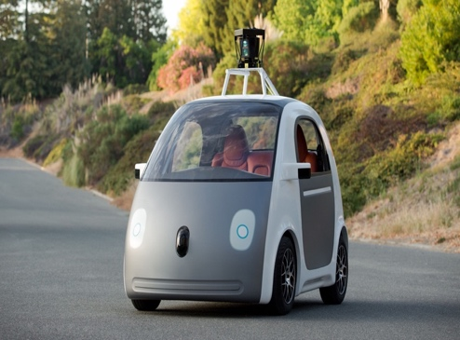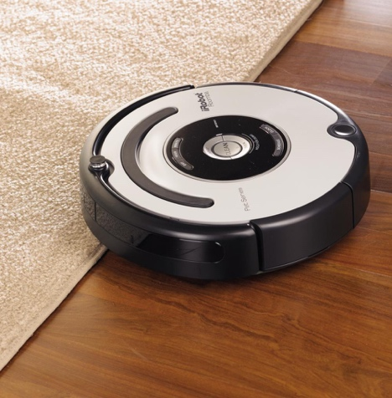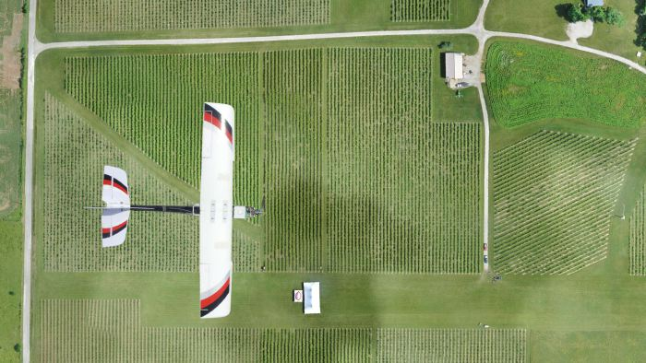

Figure ‑ (Left to Right) iRobot Roomba vacuum cleaning robot, Google self-driving car, PrecisionHawk agricultural surveying drone

Autonomous mobile robots are currently far from perfect, with mapping being the primary constraint on their performance [4] [12]. In recent years, many autonomous mapping systems have been proposed, with many showing promising results. The goal is to have mobile robots be capable of mapping their environments in real-time as they move. With a map at hand, such robots can then navigate their environments autonomously. These solutions remain costly, however, and there is a need for more economical alternatives. For example, the FastSLAM system [14], which is the basis of the Google self-driving car, can generate large-scale 2D maps as shown in Figure 1-2. However, it makes use of an expensive laser-scanning sensor; the Velodyne HDL-32E which costs USD 30,000 [5].

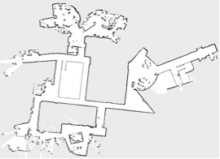

Figure ‑ Large-scale 2D map generated by the FastSLAM system

Other systems have tried to circumvent the issue of expensive laser-scanning sensors by making use of monocular cameras as a primary sensor source, rather than laser scanners, for example. Such systems then use computer vision and image processing techniques to infer distances. However, these techniques are computationally expensive, require power-hungry embedded systems, and are difficult to run in real-time systems [6].

Autonomous mapping robots are currently a very active area of research. While there are currently working systems that produce reasonable 2D maps, they are generally either overly expensive, computationally expensive, or imperfect in their mapping. As such, investment in research is required to iteratively improve on current mapping technologies. The demand for low-cost, accurate, autonomous mapping systems is currently extremely high, owing to its wide applicability in many robots. If this is not done, autonomous mapping will remain underdeveloped and an impediment to the advancement of mobile robots.

## Thesis Contribution

Our main objective in this work is to implement a low-cost autonomous 2D-mapping robot. Our contributions can be summarized as having built a low-cost robot from discrete mechanical and electronic components, which can:

* Generate a 2-D map of a mid-sized environment that includes dimensional characteristics and obstacles
* Localize itself within the environment
* Plan its own trajectories to reach points on the map given to it by a user with a given degree of accuracy while avoiding obstacles that may appear
* Communicate back and forth and transfer sizeable survey data as well as commands between the robot and a command center

## Organization of the Thesis

In the remainder of this thesis, we discuss the details of the implementation of our robot. In Chapter 2, we will review relevant background information and theory necessary for understanding how the system as a whole, as well as each of its subsystems, work in our implementation.

In Chapter 3, we present a detailed explanation of how the primary subsystems of the robot were designed. This includes the software and hardware used as well as additional implementation details necessary for practical purposes such as power supplies and motor drivers. In Chapter 4, we present the experimental results of our implementation, with some data characterizing the performance of different subsystems, along with various maps generated by the system.

We conclude this thesis in Chapter 5 by giving an overview of the various challenges faced in the implementation of the system as well as future improvements that can be made to the system.

# Background

The autonomous mapping robot described in this report is composed of four primary subsystems, all of which make use of some algorithms specific to their objectives. In this chapter, the concepts and algorithms pertaining to each subsystem are discussed, such that when they are used in the subsequent chapters, their context is clear.

## Control

### Controller

Controllers are devices that closely monitor the behavior of a system and accordingly apply certain commands to adjust their mode of operation. Nowadays, microprocessor operated systems became the most dominant form of controllers. It is famously applied in environments related to controlling speed, temperature, flow and pressure.

### Feedback Controlled Systems

Feedback controlled systems are controlled systems that make use of output measurement to readjust their actuators. Main components of these system are desired input signal, calculated output signal, error signal (the difference between output signal and the input signal), the controller and the plant [7]. The controller is responsible for passing the input signal to the plant, the plant translates this signal to an action, and then output signal is passed back to the controller to calculate the error signal, and adjust the input signal if needed.

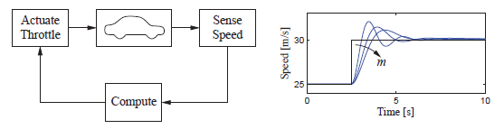

Figure ‑ Block diagram and corresponding step response of a cruise control system

Figure 2-1 shows the cruise control system of a car, which is one of the most famous examples of negative feedback systems. The system operates as follows: a desired speed is set to the system. The controller then controls the torque supplied to the engine, and the resulting car speed is measured using a speedometer. The error is calculated as the difference between the desired speed and the reading obtained from the speedometer. After getting the error signal, the controller adjusts the accelerator, hence affecting the fuel supply and changing overall torque in the engine.

### Differential Drive Models

Any robotic system requires a kinematic model that describes how motion is achieved via the actuators of the robot. For wheeled robots, a common model is the differential drive model shown in Figure 2-2 [9]. It is a model where the movement of a robot’s wheels is independent of each other, allowing the robot to move and change direction, by varying the rate of rotation per wheel. Each wheel has a dedicated electric motor that is responsible for its speed and direction of rotation. If all wheels move at the same velocity, the robot will move in a straight line. While, if the wheels on the right side move in an opposite direction to the ones on the left side, yet maintaining the same speed, the robot will rotate about its central axis. Differential Drive robots are used widely in robotics, as they are easily programmed and controlled [9].

A 4-Wheeled Differential Drive model is applied to move the robot to any point in space. The data passed to the control system specifies the linear and angular velocity. Once it is passed, the system calculates the corresponding wheel velocities that would achieve the desired velocities. To get the desired wheel drive from the linear and angular velocities, the following set of equations (Eq. 2-1, 2-2) can be derived from the geometry of a differential drive robot [8],

|  |  |
| --- | --- |
| $$V_{r}= \frac{2*v+ ω*L}{2*R}$$ | (2-1) |
| $$V_{l}= \frac{2*v- ω*L}{2*R}$$ | (2-2) |

where $V_{r}$ and $V_{l}$ are the right wheel velocity and the left velocity respectively, $ω$ is the angular velocity, *R* is the radius of the wheel, and $L$ is the distance between two opposite wheels.

### Internal Sensing and Odometry

Within a robot control system, there is always a system responsible for computing odometry, which is an estimate of the robot’s location using internal sensors. The main purpose of this system is to estimate the position of the mobile robot with respect to a reference point, usually the robot’s starting location. Through collection of data from motion sensors, the system becomes capable of knowing the distance travelled in a given time. This method is widely used in most navigation systems due to its moderate accuracy and relatively cheap cost. In our case, the motion sensors used are motor shaft magnetic wheel encoders. To determine the distance covered from the encoder signals, we use the following equations,

|  |  |
| --- | --- |
| $$Δtick=New tick-Old tick$$ | (2-3) |
| $$Distance=2*π*R*( \frac{Δtick}{N} )$$ | (2-4) |

where $N$ is the sampling rate of the wheel encoder and $R$ is the radius of the wheel.

../../../var/folders/tr/l1mqpp7d06gfdz5hs639fcb00000gn/T/com.apple.Preview/com.apple.Preview.PasteboardItems/Module2%20(dr

Figure ‑ Differential drive robot and its corresponding three arc lengths

For the robot to update its point in space ($x$, $y$, $θ$), the set of equations (Eq. 2-5, 2-6, 2-7) are used,

|  |  |
| --- | --- |
| $$x^{'}= x+D_{c} \cos{θ}$$ | (2-5) |
| $$y^{'}= y+D_{c} \sin{θ}$$ | (2-6) |
| $$θ^{'}= θ+ \frac{D_{l} - D_{r}}{L}$$ | (2-7) |

where $D_{r}$ is the distance covered by the front right wheel, $D_{l}$ is the distance covered by the front left wheel, $D_{c}$ is the average of the two distances, and $L$ is the length between the two wheels.

### Sensors

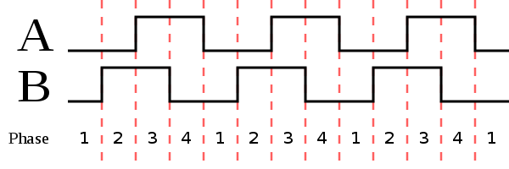

Figure ‑ Wheel encoder square wave pattern

As mentioned earlier, in a wheeled robot, typically the motion sensors used are wheel encoders. They are easy to install on the motor axes, assuming the robot allows customization to its chassis. Each wheel encoder is composed of 8 pole-magnets and 2 hall-effects to produce two square waves (out of phase by 90), as shown in Figure 2-3 [8]. Hence, it is capable of providing a total of 16 pulses per revolution (1 pulse = 22.5). With each rising and falling edge of the square waves, an encoder count is detected. The rotation speed is calculated from the frequency of the counts, and the direction of rotation is specified from the order of the counts.

## Path Planning

Path planning algorithms are essential in the context of robot exploration of unknown areas. At any time, the robot can be given a goal in the 2D space and the path planning algorithm should figure out a safe path for the robot to follow. Anytime Dynamic A* known as AD* algorithm [10] is chosen as the path planning algorithm for our application.

### AD* Algorithm Overview

AD* is a graph search algorithm that uses heuristics in its search method that makes it very fast to find a solution [10]. Anytime refers to its high speed in providing suboptimal solutions. Dynamic refers to its dynamic behavior in improving the calculated path based on changes in the surrounding environment. The downside is that it is computationally expensive compared to other path planning algorithms.

### Heuristic Graph Search

The path planning problem involves finding an optimal sequence of steps to be taken by the robot in order for it to reach a particular location on the map. The problem is formulated as a a graph data structure $G\left(S,E\right).$ The variable $S$ represents the different nodes in the graph. While the variable $E$ represents the edges that connects nodes together. For the context of path planning, the nodes represent the different states of the robot in the 2D space, while the edges represent the cost of moving from one state to another. Given that the robot is at $S_{1}$ and the goal is at $S_{g}$, the algorithm does a graph search to provide a sequence of consecutive states the robot should pass by to reach the goal trying to minimize the total cost.

AD* builds a search tree beginning at the robot’s initial position. The tree expands from each state to other connected states that haven’t been discovered before. The states at the bottom of the search tree that need to be expanded are known as frontier states. The search tree keeps expanding till the goal is reached. AD* algorithms uses a fast exploration strategy to reach the goal.

Different heuristics have been introduced that define the order of the frontier states to be explored. The cost function $f(s)$, expressed in Eq. 2-8 is used to calculate the cost for all frontier states. The state with the minimum cost indicates that it is a promising state to be on the path with the least cost, so it gets explored first. The function $g(s)$ defines the accumulated cost beginning from the initial state till the state $s$. The function $h(s)$ is a heuristic cost that estimates the cost from the state $s$ to the goal state. To guarantee optimality of the algorithm, $h\left(s\right)$ has to be less than or equal to the real cost. The benefit of $h\left(s\right)$ is that it guides the graph search in the right direction towards the the goal. Practically, the costs of frontier cells are kept in a priority queue so that they are ordered by their cost value. The state with the least cost is taken from the priority queue to get expanded first. The variable $ϵ$ is a factor that trades off the speed of a given solution to its optimality. Giving it a value 1 guarantees an optimal solution to be provided if available. Raising the value above 1, allows a solution to be provided faster but the solution becomes suboptimal.

|  |  |
| --- | --- |
| $$f\left(s\right)= g\left(s\right)+ϵ*h(s)$$ | (2-8) |

### Dynamic Behavior

The dynamic behavior of the AD* algorithm is very important in the exploration process. The algorithm has to plan a path from the robot’s position to the goal in an unknown environment or in an environment that is partially known. Moreover, the known part of the environment is actually based on a probabilistic model that estimates the location of obstacles and free space. As the robot moves, it gains more knowledge about the environment. Knowing that the environment has changed the path should be planned again to cope with the new environment. One way to do that, is to do graph search again from scratch. However, that is very computationally expensive and slow.

This lead to the dynamic behavior of the AD* algorithm in which the previously planned path is used to generate a new path in an efficient way. That is done in AD* algorithm by limiting the states to be expanded or explored only to states whose path to the goal get affected by the environment changes and to states whose change in path cost would affect the path cost of the initial state.

To limit the expanded states to only the states whose path to the goal get affected, two cost values are stored for each state. The first value $g\left(s\right)$ is the total cost from the initial state to the state $s$. The second value $rhs\left(s\right)$, expressed in Eq. 2-9, is a one step look ahead cost. A state that has $g\left(s\right)$ cost not equal to $rhs\left(s\right)$ means that this state is inconsistent and is affected by the environment changes. Inconsistent cells get expanded again to re-compute a new path.

|  |  |
| --- | --- |
| $$rhs\left(s\right)= \left\{ \begin{aligned}0 if s=s_{goal} \\ \min_{s^{'}∈Succ\left(s\right) }\left(c\left(s,s^{'}\right)+g\left(s\right)\right) Otherwise\end{aligned}\right.$$ | *(2-9)* |

To limit the expanded states to only the states whose path to the goal get affected, inconsistent cells are put in a priority queue where they are ordered by the cost value $f\left(s\right)$ explained before. The state with the least cost get expanded first. Expansion of states terminates when the least cost is greater than the cost of a predefined solution because that means there is no further improvement and that these inconsistent states will not lead to the least cost path.

### Anytime Solution

In complex environments where there are many obstacles or the number of states is big, searching for the optimal solution takes a lot of time. In some situations, reaching a suboptimal solution in a shorter amount of time is more convenient. Algorithms that provide suboptimal solutions at a required time are called “anytime algorithms” and AD* is one of them.

As shown in Eq. 2-8, increasing the $ϵ$ value allows a solution to be provided faster. This is because the heuristic cost that estimates the cost to the goal has more weight so states that lead to the goal get expanded first. However, increasing the $ϵ$ value decreases the quality of the planned path. That is because the search is more guided by the heuristic cost that is an estimation rather than the real cost $g\left(s\right)$.

The AD* algorithms works by providing a fast suboptimal solution given an initial $ϵ_{0}$. The quality of the search is then improved through successive search iterations. At each iteration, the initial $ϵ_{0}$ is decreased till it reaches 1 by the final iteration which provides the optimal solution. To make each iteration fast, each state is allowed to be expanded once. By the end of the iteration if it is found to be inconsistent, meaning $g\left(s\right)$ is not equal to $rhs\left(s\right)$, then it is marked as inconsistent state. It is then expanded again in the following iterations. This guarantees that each iteration is fast enough to provide successive improvements on the planned path.

## Simultaneous Localisation and Mapping

### Overview

Simultaneous Localization and Mapping (SLAM) is the problem of estimating a robot’s trajectory through an unknown environment. It involves localizing a robot in an environment that one does not yet have a map of. Instead, a map needs to be constructed as the robot moves through the environment, against which the robot localizes itself. The problem is challenging because solving for either one of the two unknowns requires information about the other. Without an understanding of the environment surrounding a robot (i.e. mapping) and where it is with respect to that environment (i.e. localization), a robot cannot make meaningful progress towards its ultimate goal - be it search and rescue, travelling to a specific destination, or cleaning a room. The independent localization and mapping problems will be outlined briefly, before proceeding to describe the SLAM problem of concurrently solving the two.

### Localization

Localization is the process of determining where a robot currently is with respect to a certain reference frame. Assuming that a map of the environment with which the robot is interacting is on hand, the problem involves a sequence of motions followed by measurements, from which an estimate of the robot’s state is found that is most consistent with the motions and observed measurements.

### Mapping

Mapping is the process of determining a map of the environment in which a robot is moving. Assuming that the location of the robot is known relative to a certain reference point, then mapping involves estimating a map that is most consistent with the sequence of robot locations and sensor measurements. For the problem of mapping to be well defined, a certain map representation needs to be chosen to model the real world. For the purpose of 2D mapping, there is a natural geometric representation of maps called an occupancy grid map.

An occupancy grid map [11] discretizes the world into a grid of cells, each of which is assigned a probability describing the likelihood of whether it is occupied (by a wall, for example) or not. Figure 2-4 shows a typical occupancy grid map from a successful mapping.



Figure ‑ An occupancy grid map of the MIT CSAIL Building [2]

A number of simplifying assumptions are made when mapping with occupancy grid maps:

* The environment is static
* The probability of any cell being occupied is *independent* of that of any other cell

A Markov assumption is made with regards to the dependence of the cell’s occupancy given the sequence of the robot’s poses and measurements. Namely, only the previous robot pose and observation is considered relevant to the occupancy of a cell. This greatly simplifies the computation of each cell’s probability of being occupied. This comes at the cost of losing important information from the entire sequence.

These probabilities are computed based on the measurements taken by the robot (according to its sensor model) at specific locations, using Bayes rule to compute a posterior distribution of each cell $m_{i}$ being occupied, given the prior. Using these assumptions, Eq. 2-9 [12] can be derived formally as:

|  |  |
| --- | --- |
|  | (2-9) |

Using the independence assumption, the joint probability of the entire map is given by:

|  |  |
| --- | --- |
|  | (2-10) |

Of the assumptions made, the independence assumption of cells is the most significant one. It offers a significant reduction in computational complexity by greatly simplifying the computation of the joint distribution. However, it is clearly false since the occupancy of neighboring cells is in fact highly correlated. This, in conjunction with motion and sensor noise, can result in significant misalignment of cells over time, resulting in poor maps. Steps are usually taken to align consecutive map estimates to minimize this error via a process known as scan matching [12]. Figure 2-5 [12](left) shows accumulated drift because of strong correlations. Figure 2-5 (right) shows a corrected map using incremental alignment.

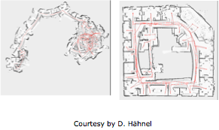

Figure ‑ Drift resulting in an unintelligible map (left) subsequently corrected (right)

### Mathematical Approaches to State Estimation

In the previous sections, the problems of localization and mapping were generally defined. The two problems are state estimation problems, both of which can be solved using essentially the same mathematical tools. In this section, we seek to make this notion mathematically precise and explain the mathematical approaches that can be taken to address state estimation problems.

There are 3 main paradigms for estimating the desired state in localization and mapping:

* Kalman Filters
* Particle Filters
* Least-Squares Estimation

The first two are based on the notion of recursive state estimation using the Bayes Filterframework, while the third involves computing an estimate of the state that minimizes the mean-squared error found in observations. This is done by solving an over determined system of equations, as a least-squares optimization problem. With regards to the Bayes Filter framework, it breaks up the estimation problem into two distinct steps:

* **Prediction Step -** A prediction of what the robots’ state should be after executing a certain command, given its previous state.
* **Correction Step -** Updating the belief of what the robots’ state is after taking into account a measurement/observation from the environment.

For the prediction step, there is an associated **motion model,** which is a distribution that characterizes the uncertainty in robot motion. For the correction step, there is an associated **sensor model,** which describes the uncertainty in sensor data. Often the model of choice is a Gaussian, where it is assumed that the true motion is a sum of the motion command and additive zero-mean Gaussian noise. As such, characterizing a motion model is often reduced to a case of characterizing the variance in a robot’s motion. It is then assumed that the motion is normally distributed as $N∼ (μ,σ^{2})$, where $μ$ is the motion command, and $σ^{2}$ is the variance in the robot’s motion. The same applies to sensor models. As mentioned, two main paradigms exist for SLAM using the Bayes Filter framework:

* **Kalman Filters -** Gaussian, Unimodal, Linear/Linearized Models [12]
* **Particle Filters -** Non-Parametric, Sampling Based Monte-Carlo Methods [12]

### Simultaneous Localization and Mapping

With the problems of localization and mapping each independently understood, now comes the problem of solving the two simultaneously. Mathematically, the SLAM problem is defined as follows:

**Given:**

A sequence of robot controls/commands: $u_{1: t}=\{u_{1},u_{2}, … u_{t}\}$

A sequence of observations/measurements: $z_{1: t}=\{z_{1},z_{2}, … z_{t}\}$

**Desired:**

A map of the environment: $m$

The path (a sequence of poses) taken by the robot: $x_{1: t}=\{x_{1},x_{2}, … x_{t}\}$

The core of the problem is to estimate the conditional probability distribution of the desired quantities, given the controls and observations. Accordingly, we wish to estimate:

|  |  |
| --- | --- |
|  | (2-11) |

In other words, we wish to estimate the sequence of robot state (i.e. its path) as well as the map of the area it is in, given the entire sequence of motion commands and sensor observations made. The same paradigms that are applied to the localization and mapping problems can be invoked to solve the SLAM problem, with some additional considerations. In our implementation, an algorithm from the particle filter paradigm is used, known as **FastSLAM using Rao-Blackwellized Particle Filters** [13]. We will now elaborate on particle filter methods.

### Particle Filters

Particle filter **localization** is a non-parametric approach to estimation. Rather than attempting to estimate the parameters of a known distribution, as is the case in Kalman filter approaches, particle filters make no assumptions about the underlying distribution of the robot’s state. It is a Monte-Carlo based approach, where $n$ random state estimates called particles are generated. When the robot moves, all $n$ particles are updated in accordance with the motion model of the robot. Then when the robot makes a measurement, the particles are each compared to the robots’ observations and are accordingly given a likelihood weight. Particles are then resampled in proportion to how likely they are. Particles that show low likelihood are more likely to be discarded and get replaced by new ones. As $n$ increases, the model converges to the target distribution, as implied by the weak law of large numbers. Because the model is non-parametric, it can model any arbitrary probability distribution given a sufficient number of particles. Particle filters can be extended to SLAM problems, by having each particle encode not only the robot’s pose, but an entire occupancy grid map as well.

### FastSLAM

The FastSLAM algorithm [14]is a direct analog to the particle filter localization method, except in this case each particle is a vector encoding the robot’s position, as well as the occupancy of a grid map. In FastSLAM, $n$ particles are spawned, and for every motion taken by the robot, all of them are updated according to the robot’s motion model, which usually assumes that the robot’s motion has Gaussian noise added to it. The robot then senses the environment. Based on its sensor readings, a likelihood score is computed for every particle. The likelihood score is a measure of how consistent the pose encoded by the particle is with the map encoded by the particle. Particles are then resampled, with probability proportional to their likelihood.

The algorithm works by selecting a set of landmarks from each particle’s map estimate that can be used as reference points. These landmarks are usually a subset of some of the cells in the occupancy grid map encoded by the particle. Subsequently, the robot moves and uses its motion model, along with odometry information from the robot to update the pose for all $n$ particles. After updating each particle’s pose, the robot senses the environment once more. By comparing what the sensor sees to the map estimate of that particle, a likelihood weight is assigned to each particle. The $n$ particles then get resampled with replacement, giving the more consistent particles a higher probability of getting resampled. Assuming a sufficient number of particles are used initially, the algorithm converges to the target distribution.

**Complexity:**

$Ο(nm)$, where $n$ is the number of particles and $m$ is the number of landmarks [14].

**Limitations:**

For larger maps in particular, FastSLAM can become expensive in its memory requirements, since more particles are needed to have sufficient variety, as well as the fact that each particle would be a larger vector, since the map would have to contain more cells. To address these issues, FastSLAM was improved upon by using a technique known as Rao-Blackwellized particle filtering [13].

### Rao-Blackwellized Particle Filtering

Rao-Blackwellized particle filters [13] dramatically reduce the memory requirements incurred by FastSLAM by addressing the independence assumptions used in FastSLAM [14]. In particular, the robot’s pose estimate takes into account its previous measurement along with it’s current odometry measurement of its motion. This means that when particles are generated, they are generated from a distribution which more accurately reflects the robot’s pose. This leads to fewer particles being needed, since the particles generated are generally reasonable estimates of the map and robot pose. The Rao-Blackwellized particle filter samples near the maxima of the robot’s pose distribution, avoiding wasting memory on particles that were likely to be poor estimates in the first place. Owing to memory savings, Rao-Blackwellized particle filters also have the added benefit of not requiring to identify specific landmarks from sensor data, but rather they can simply use a sampled subset from raw sensor data. In other words, by reducing the number of particles $n$, it becomes possible to increase the number of landmarks $m$, to the point where all points in the occupancy grid are considered landmarks.

Furthermore, the Rao-Blackwellized particle filter does not resample every iteration, rather it resamples based on a criterion that determines whether or not the current estimates have on average dropped below an acceptable threshold. This reduces the computational complexity of the algorithm and offers the opportunity for faster convergence, should an existing particle prove to be a good estimate. Asymptotically, the algorithm is computationally the same as FastSLAM with an $Ο(nm)$ running time, where $m$ is the number of landmarks used. As stated earlier, in the Rao-Blackwellized particle filter, $m$ is often equal to the number of cells in the occupancy grid map. In practice however, it is capable of handling significantly larger maps owing to the aforementioned improvements.

## Depth Sensing

The etymology of the word “Odometry” relates us back to the Greek word *Hodometron,* which means road measurement. Currently, odometry means the usage of data collected from different motion sensors to estimate the trajectory and travelled distance. The main focus of this report is visual odometry in robotics, which depends on using image analysis to formulate an estimate of position and orientation of robot.

Visual odometry techniques are categorized based on two main criteria, namely the type of the algorithm used which can be one of two things feature based approach or appearance based approach. Another way you can categorize it is dependent on the type of sensors used in collecting the visual data. Typically, researchers would use **Laser Imaging Detection and Ranging (LIDAR)** for the purpose of depth data collection; they also use **ultrasound sensors** for more or less the same purpose. Nevertheless, this is not the focus of this literature survey nor is it adequate for our application seeing that the price of a LIDAR array ranges from $8000 to $30000 [5]. The ultrasound sensor array is also expensive and not as accurate as the latter proposed sensors. The current state of the art is looking at cutting the costs of robotic localization and mapping by deploying non-expensive sensors, such as the ones shown in Figure 2-6, that can collect enough data and still maintain an acceptable level of accuracy. The odometry techniques within each of the formerly assigned categories is also divided into techniques deployed with: **(a) Monocular Cameras (b) Omnidirectional Cameras (c) RGB-D Cameras.**

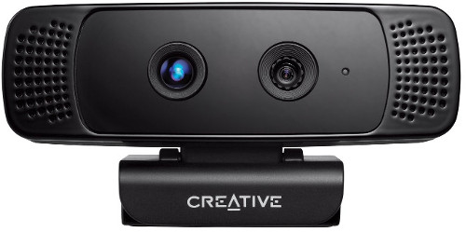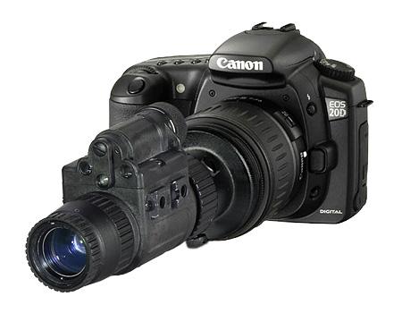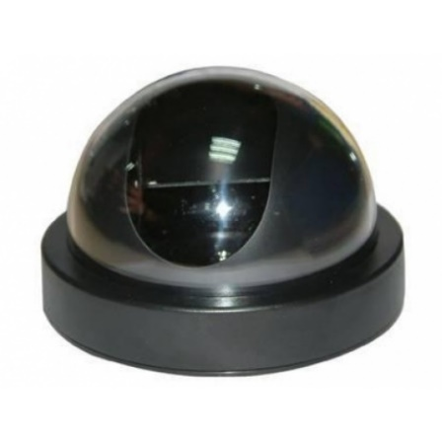

Figure ‑ Different camera sensors used in visual odometry techniques

Figure 2-7 shows an encompassing figure of the different algorithm types previously surveyed.

Figure ‑ Classification of different techniques used in visual odometry

The main aim of this section is to create a relation between the visual scene captured by the camera and the coordinate position of the car that we get through wheel encoders. It also relates the visual features extracted from the image to the mapping of the place using SLAM. The robot, hence, needs to maintain a structured representation of all the different scenes and the linking relation between them (visual odometry). Understanding this link allows one to create a coherent map, solving the SLAM problem. After highlighting the marker between both parts of the algorithm, we are going to be briefly discussing the various meanings of those techniques focusing on depth sensing as the main concern of this report being implemented in chapter 3.

### Feature Based Approaches

#### Overview

The extraction of visual features from images is a common method in computer vision techniques to decrease the size of the search space and minimize the image representation in different problems. In feature-based approaches, the features are extracted relative to a key frame or to a filtering process of pixel differences. There are many ways to choose features; an example of that would be edge detection [15] or a filtering process common to all frames [16]. Features are usually compared to a key frame for further analysis. The main limitation of feature based depth estimation approaches are that despite the fact that they reduce the search space by focusing on specific features rather than pixel level analysis, they add the overhead of feature matching. This requires rotational and scaling optimization techniques, which are heavily computational like RANSAC algorithms [17]. Another problem is that often times feature extraction drops other features or information that might be importantly conveyed through the image and that’s why feature space selection is a very important part of the algorithm. Yet feature-based approaches are very popular with RGB-D sensors since it minimizes the computational cost drastically. On the other hand, some of the feature descriptors can’t be used with monocular cameras because they require an extra normalization step that adds an overhead to any of the following algorithms. Moreover, Stereo cameras fail in texture-less surfaces that have little to no features [18].

Table ‑ Comparison of different feature-based approaches in visual odometry

|  |  |  |  |  |  |
| --- | --- | --- | --- | --- | --- |
|  | **SIFT** | **SURF** | **ORB** | **FAST** | **LINE FEATURES** |
| **Name** | Scale Invariant Feature Transform | Speeded Up Robust Features | Oriented FAST & Rotated Brief | Features from Accelerated Segment Test | Edge Detection |
| **Sources using them** | [18] | [18][19][20] | [18][20] | [21] | [22] |
| **Problems** | * Consistency * Depth information accuracy, requiring Random Sample Consensus (RANSAC) algorithm | | | - Must Select Key frame features to track them through rest of frames  - Requires RANSAC  - Requires Umeyama Algorithm | - Requires Gaussian Filtering  - Requires Contour Line Formulation and CCL |
| **Available in OpenCV** | Yes | Yes | Yes | Yes | Yes |
| **Sensors** | RGB-D | | | Monocular Camera | RGB-D |

Figure ‑ Generic steps of feature-based approaches

As shown in figure 2-8 there are many ways to implement visual odometry approaches that don’t depend on actual pixel values. On the other hand, they mainly depend on representing an image in terms of concise low dimensional set of features that help later on represent large sum f data in smaller representation. The different features described in Table 2-1 are examples from literature on what can be used. Problems with feature based approaches include accuracy, large search space and the overhead of optimization techniques required to guarantee accurate use of depth data in case of using RGB-D sensors.

### Appearance Based Approaches

Appearance based approaches in computing visual odometry information are based on relating pixels into one frame to those in another frame. In other words, tracking the macroscopic movement of an object from one frame to another relative to camera movement by relating the microscopic movement of pixels or depth points [17] [23].

#### Pixel to Pixel mapping techniques

Figure ‑ General Steps of appearance-based approaches dependent on pixel by pixel mapping

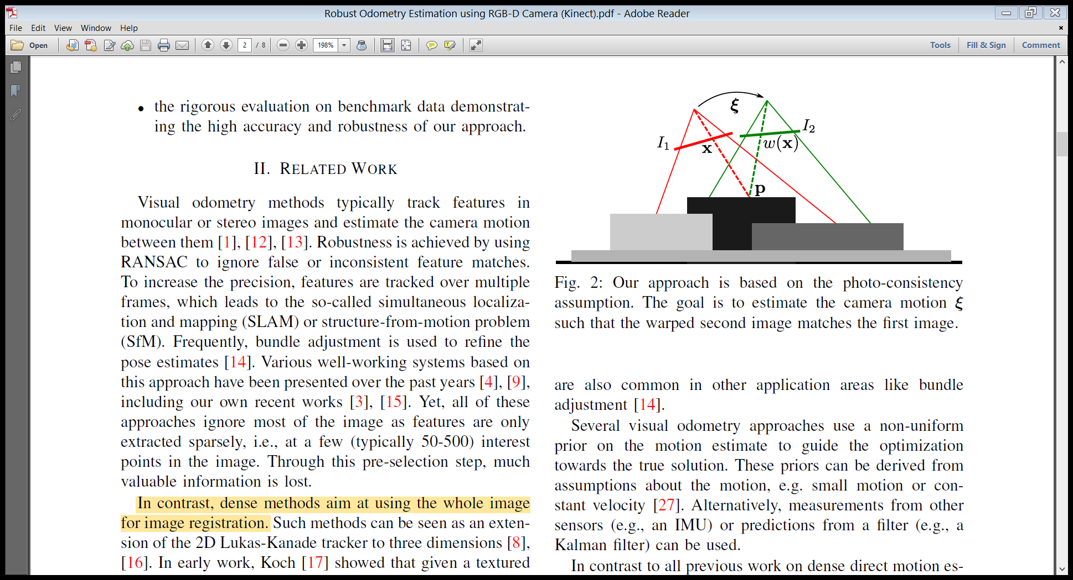

Figure ‑ Mapping of pixels between two frames

Pixel to pixel mapping is based on creating a time warping function. That is basically a transformation from the first image to the second image through time. One advantage of this method is that it is not closely tied with scale ambiguity as they do not sense depth and scale. It depends on the analysis of the imagery to estimate distances. Hence scale is relative. In addition to higher accuracy and robustness in particular in environments with little key points than feature based approaches, this provides substantially more information about the geometry of the environment. Still if compared to feature based exhaustiveness they both have very large search space. The general steps of pixel to pixel mapping techniques are shown in Figure 2-9, with Figure 2-10 illustrating the different variables defined for two consecutive frames.

The first two steps involve two independent error sources. The first type is the geometric error, which originates from noise and affects the first step basically describing an error in position. Secondly, the photometric error originates from noise in the images $I_{0}$, $I_{1}$. This affects the third step which is basically an error in intensity measurement of the image which effectively hinders the process of disparity measurement between frames and the choice of key frames*.* The main idea used in this is to accumulate the square of both errors to measure the variance of the depth from the equi-polar line in an assumed normal distribution.

#### Depth Sensing

Depth sensing methods [24] [25] involve combining multiple camera frames or directly using depth sensors to produce a 3D representation of the scene. Figure 2-11 shows the general steps involved in such methods.

Figure ‑ General steps of depth sensing methods

### Mix of Both Feature Based and Appearance Based

This approach by Andreasson et al [26] uses **Omnidirectional Camera** for collection of data. A measure of image similarity is used to estimate the relative pose between corresponding images (“visual relations”) and the uncertainty of this estimate. The SLAM problem is being solved using Multiple Linear Regression, MLR, graph. The nodes of the graph are composed of different poses with the edges between them describing variance between them. The fact that this approach doesn’t depend on features divides the covariance matrix to two parts one related to odometry relations and visual similarity relations. As shown in Eq. 2-12, a diagonal covariance matrix is used to infer the odometry relation between two successive frames using the total distance covered between two successive frames and the total angle rotated and getting a weighted average of their squares where $d$ and $θ$ are the total distance and total rotation angle between two consecutive frames. The $δ_{x}$ parameters relate to the forward motion, the $δ_{y}$ parameters to the side motion, and the $δ_{z}$ parameters to the rotation of the robot.

|  |  |
| --- | --- |
| $$C_{0}=\left[\begin{matrix}d^{2}δ_{x}^{2}+θ^{2}δ_{x}^{2} & 0 & 0 \\ 0 & d^{2}δ_{y}^{2}+θ^{2}δ_{y}^{2} & 0 \\ 0 & 0 & d^{2}δ_{z}^{2}+θ^{2}δ_{z}^{2}\end{matrix}\right]$$ | (2-12) |

They then use features extracted to further investigate the relation between two consecutive nodes. The SIFT descriptor is used in creating the search space for matching features between image A and image B. The matching is determined using the following empirical criterion: Euclidian distance is measured between two features and minimalized and accepted if it is 60% less than the second minimum.

The features are then combined into a 10-bin histogram. The relative rotation is estimated as the maximum of a parabola fitted to the largest and one to its left and right. The covariance matrix for the robot pose motion is created using the relative rotations and displacements of the robot extracted from the feature mapping. This algorithm also carries out an optimization algorithm that selectively matches specific frames not all consecutive frames decreasing the computational load of the algorithm significantly.

## Summary

In this chapter, we reviewed the necessary technical details pertaining to each subsystem of our robot. For the control subsystem, we explained differential drive models along with the mode of operation of wheel encoders. We then detailed the AD* algorithm to be used in path planning, and Rao-Blackwellized particle filters to be used in the SLAM subsystem. Finally, we explained depth-sensing techniques which are used in our implementation. In the following chapter, we will proceed to describe the implementation of our robot. Our aim is for the context to be clear in the description of each subsystem, having reviewed the relevant technical background in this chapter.

# System Design

In this chapter, the design of the proposed autonomous mapping robot is discussed in detail as well as details of the implementation. The chapter will begin with an overview of the system design at a high level, followed by sections discussing the details of each subsystem and its implementation.

## High-Level Description

The robot consists of many subsystems, all of which communicate with others. The high-level design of our system is a core stack of subsystems for autonomous navigation. These subsystems are:

* Control Subsystem
* Path Planning Subsystem
* Simultaneous Localisation and Mapping (SLAM) Subsystem
* Depth Sensing Subsystem

These subsystems communicate with each other via a method of message passing. Table 3-1 outlines the role of each subsystem, and how it communicates with other subsystems. As seen in the table, most of the subsystems take as inputs the outputs of other subsystems. In implementation, different subsystems are run on different platforms. This is because certain subsystems require more computational power, such as SLAM, whereas others require direct interfacing with hardware, such as control. In our implementation, three separate platforms were used:

* Laptop running Ubuntu Linux 14.04
* NVidia Jetson TK1 embedded system
* Arduino Microcontroller

Table ‑ Primary subsystems of the robot

|  |  |  |  |
| --- | --- | --- | --- |
|  | **Role** | **Inputs** | **Outputs** |
| **Control** | * Directly interfaces with the car’s motors. * Executes velocity commands to move the car smoothly. * Maintains odometry estimates of car’s position. | * Velocity commands | * Odometry * Motor commands |
| **Path Planning** | * Determines sequence of velocity commands to get from one point to another * Avoids intermediate obstacles that may arise | * Current map estimate * Odometry | * Velocity commands |
| **SLAM** | * Incrementally build a map of the environment * Localize the robot with respect to current map | * Sensor data * Odometry | * Current map estimate * Current pose estimate |
| **Depth Sensing** | * Acquire depth information about the surrounding environment | * Physical environment/ light | * Usable sensor data |

Table 3-2 maps subsystems to the platforms on which they run, as well as the physical communication link used between platforms.

Table ‑ Platform to subsystem map and communication links

|  |  |  |
| --- | --- | --- |
|  | **Subsystems** | **Communication Channels** |
| **Laptop** | Path Planning | * Wi-Fi link to NVidia Jetson TK1 |
| **NVidia Jetson TK1** | Depth Sensing, SLAM | * Wi-Fi link to Laptop * Serial USB link to Arduino Microcontroller |
| **Arduino Microcontroller** | Control | * Serial USB link to NVidia Jetson TK1 |

Depth Sensing

SLAM

Path Planning

Control

Car Motors

Environment

**Sensor Data**

**Map**

**Odometry**

**Odometry**

**Velocity Commands**

Jetson TK1

Arduino

Laptop

Figure ‑ Communication between subsystems on the robot

With this in mind, the block diagram above in Figure 3-1 illustrates the communication of information within the system. It should be noted that for the above system to work, the different subsystems must be synchronised. As such, the implementation should have a global time reference. Furthermore, for the system to be modular, the implementation of each subsystem should not depend on the implementation of others as a principle of good design. However, the interface between subsystems should be consistent such that the subsystems can communicate reliably with each other. For example, the odometry data that’s sent to the path planning subsystem should be identical to that sent to the SLAM subsystem, so the the subsystems should agree on a standard message structure. Given these considerations, it was decided that the Robot Operating System would be a suitable framework to use for our implementation.

## The Robot Operating System

The Robot Operating System (ROS) is a collection of tools and libraries which is meant to facilitate the development of robot systems [27]. ROS organises a system as a set of independent subsystems called nodes. Each node is independent of other nodes, and communicates with other nodes using using message streams handled by ROS. ROS manages message streams called topics which are the channels of communication in a ROS system [28]. Every node can publish topics, or subscribe to topics. Therefore, if one node wishes to send data to another node, it will simply publish that data on a topic, and the other node can receive that data by subscribing to that topic. ROS has a set of standard messages that are used for various tasks, such as a standard velocity command message.

ROS was chosen as a framework to use in our implementation primarily for two reasons. Firstly, the publish/subscribe communication model greatly facilitates the interfacing between our different subsystems. Secondly, in addition to the underlying communications framework, ROS has many efficient implementations of key algorithms that are used in the system, such as particle filter algorithms for SLAM, as well as simulation and visualisation tools which are very practical when testing and using the system, and are necessary for producing maps without writing code for rendering graphics.

The task of robot navigation is common enough that ROS has a navigation stack designed to facilitate the process of implementing an autonomous navigation robot [29]. The stack defines the different nodes that should exist in the system, as well as the interfaces that should exist between them. It is essentially equivalent to the system design that was shown in Figure 3-1. To translate our system design to a ROS system, the various subsystems are either implemented as ROS nodes to fit the navigation stack’s standard, or make use of existing ROS nodes in the navigation stack. For the interfaces between subsystems, we define ROS topics for each data type and use one of ROS’s standard messages for each topic. Figure 3-2 is a graph showing the nodes provided by the navigation stack, along with the nodes that are assumed to be implemented by the user.

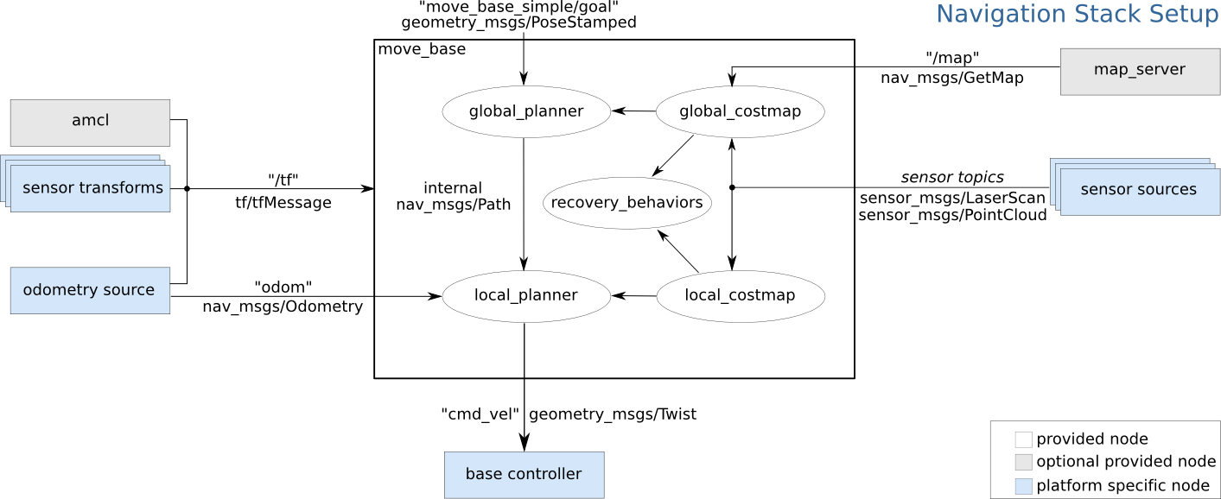

Figure ‑ ROS Navigation Stack block diagram

The square in the centre of the diagram titled “move_base” is a node containing five other nodes, and is equivalent to the path planning subsystem in our design, though the choice of algorithms to be used can be configured either within the provided nodes, or by replacing provided nodes with custom written nodes. There is also an additional node required for “sensor transforms”. This is a utility node in ROS which is responsible for unifying the coordinate frames of the different sources of data on the robot itself, e.g. the sensors and the motor controllers [30]. For example, when the depth sensor makes certain measurements, this node transforms that measurement to the coordinate frame of the robot’s center rather than the coordinate frame of the camera sensor. That way, the path planner can plan correctly, without having an offset on it’s position.

Table 3-3 shows the correspondence between our system design and the ROS navigation stack. It should be noted that since mapping is not required for navigation, the ROS navigation stack does not require a SLAM node, only a localisation node. For our purposes however, we use a particle filter SLAM node called “gmapping”.

Table ‑ Mapping from system design to ROS navigation stack

|  |  |  |  |
| --- | --- | --- | --- |
| **Subsystem** | **ROS Node(s)** | **Inputs/Outputs** | **Topics/Messages** |
| Control | base controller | Velocity Commands | Subscribed to: cmd_vel  Message: geometry_msgs/Twist |
| odometry source | Odometry | Publishes to: odom  Message: nav_msgs/Odometry |
| Path Planning | move_base | Map | Subscribed to: map  Message: nav_msgs/OccupancyGrid |
| Odometry | Subscribed to: odom  Message: nav_msgs/Odometry |
| Velocity Commands | Publishes to: cmd_vel  Message: geometry_msgs/Twist |
| SLAM | gmapping (not required in navigation stack) | Sensor Data | Subscribed to: sensor  Message: sensor_msgs/LaserScan |
| Odometry | Subscribed to: odom  Message: nav_msgs/Odometry |
| Map | Publishes to: map  Message: nav_msgs/OccupancyGrid |
| Depth Sensing | sensor sources | Sensor Data | Publishes to: sensor  Message: sensor_msgs/LaserScan |

Figure 3-3 illustrates the mapping by showing the two systems side-by-side. The figure disregards some of the additional ROS nodes such as the coordinate frame transform nodes for the purpose of clarity, pointing attention towards the primary subsystems only.

Depth Sensing

SLAM

Path Planning

**Sensor Data**

Control

**Map**

**Odometry**

**Velocity Commands**

**Odometry**

sensor source

gmapping

**sensor**

move_base

**map**

**odom**

**cmd_vel**

base controller + odometry source

**odom**

Having presented a high-level description of the system design, the interaction between subsystems, and how this was mapped to ROS, in the following sections, the individual subsystems will be detailed in greater depth, in terms of hardware used, platform specific software, as well as their implementations as ROS nodes to communicate with the rest of the system.

Figure ‑ Illustration of system design and its implementation in ROS

## Control Subsystem

The control subsystem is responsible of the actual movements of the car given any command. With this in mind, there are some specific components as well as some specific responsibilities the robot must perfect in order for the rest of the components to of the project to function correctly.

There are five main hardware components used in the complete system.

* 2 Wheel Encoders
* 4-Motor driver Board
* Arduino Mega Board
* NVidia Jetson Board
* Camera – SoftKinetic DepthSense

As far as car control is concerned, it interacts with the first three components only, as shown in Figure 3-4.

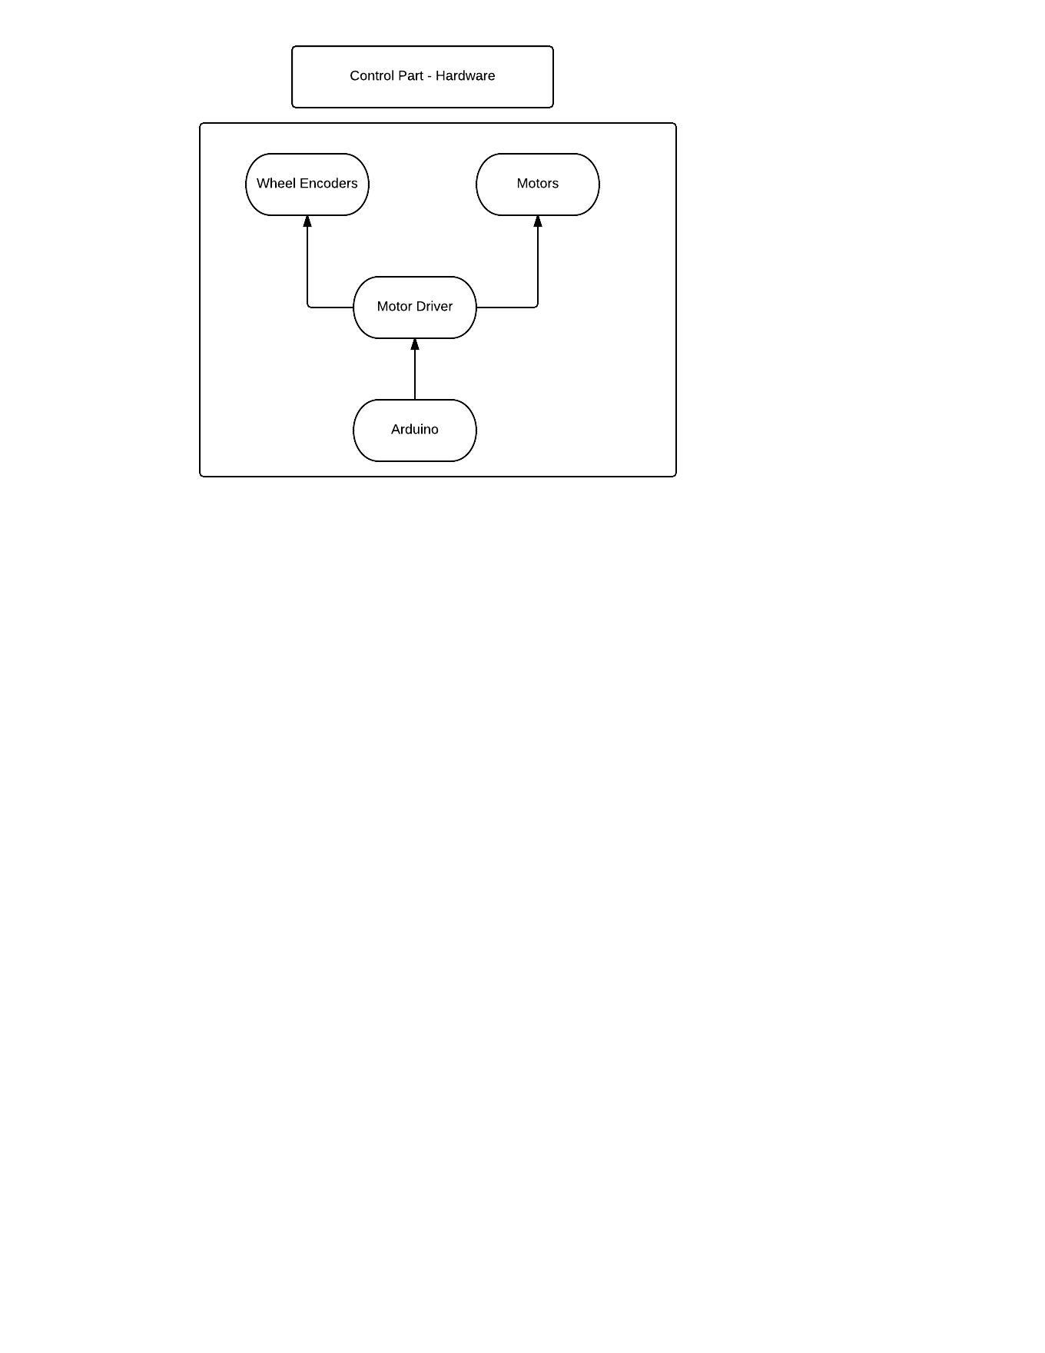

Figure ‑ An illustration of communication between different hardware elements in the control subsystem

### Main Control Responsibilities

Wheel Encoders have been used in order to calculate the distance travelled as well as providing *X,Y*, and $Θ$ of the car’s position relative to its starting point. After having those coordinates, linear and angular velocities can both be calculated if we can keep track of the time taken for the travelled Distance. All the calculations mentioned earlier are done within the Arduino Mega board.

The Arduino receives some parameters from the Jetson board such as specific Linear Velocity and Angular Velocity. Given those Parameters, Left velocity and right velocity are calculated. Those Velocities are then translated into actual motor speed that can be directly put into the motor function as a pulse-width modulation (PWM) value and start moving the car accordingly. That has been done through the mapV() function that will be discussed briefly. The control system functionality is apparent in Figure 3-5.

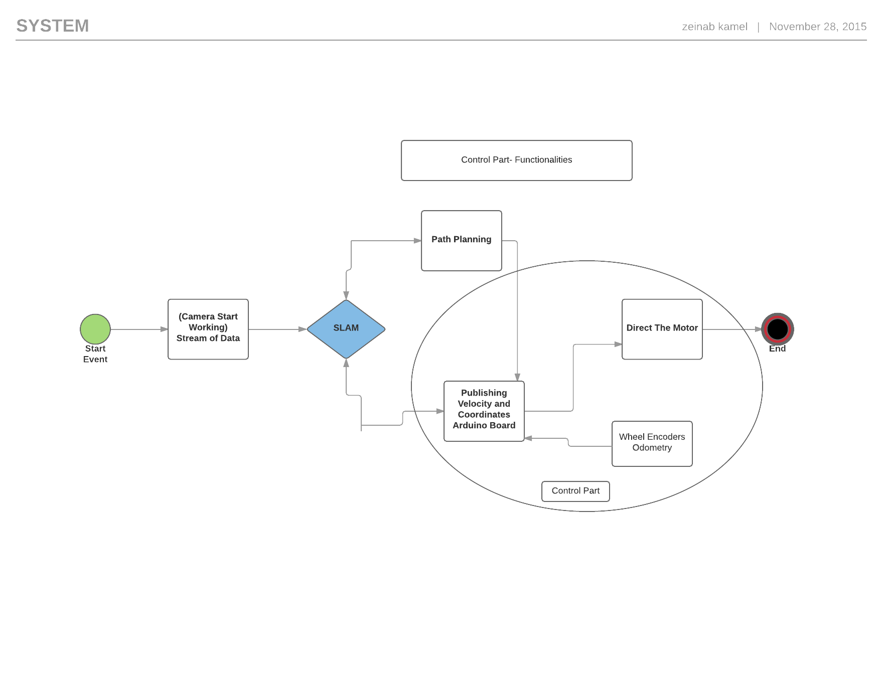

Figure ‑ Illustration of the role of the control subsystem in the system as a whole

### Arduino Board

The Arduino board is being used as a middle point. It keeps receiving information and publishing information as well. The information it keeps receiving are the two parameters Linear Velocity and Angular Velocity that adjust the motor speeds and hence control the manoeuvring. However, the information it receives is calculated according to the information the Arduino had published such as its position and its velocities.

Therefore, it is a feedback loop. One of the main advantages of our system is that PID controller was not used since the system already contains its own feedback loop that keeps adjusting the motor speeds, car position and orientation while it is moving. The feedback flow is illustrated in Figure 3-6.

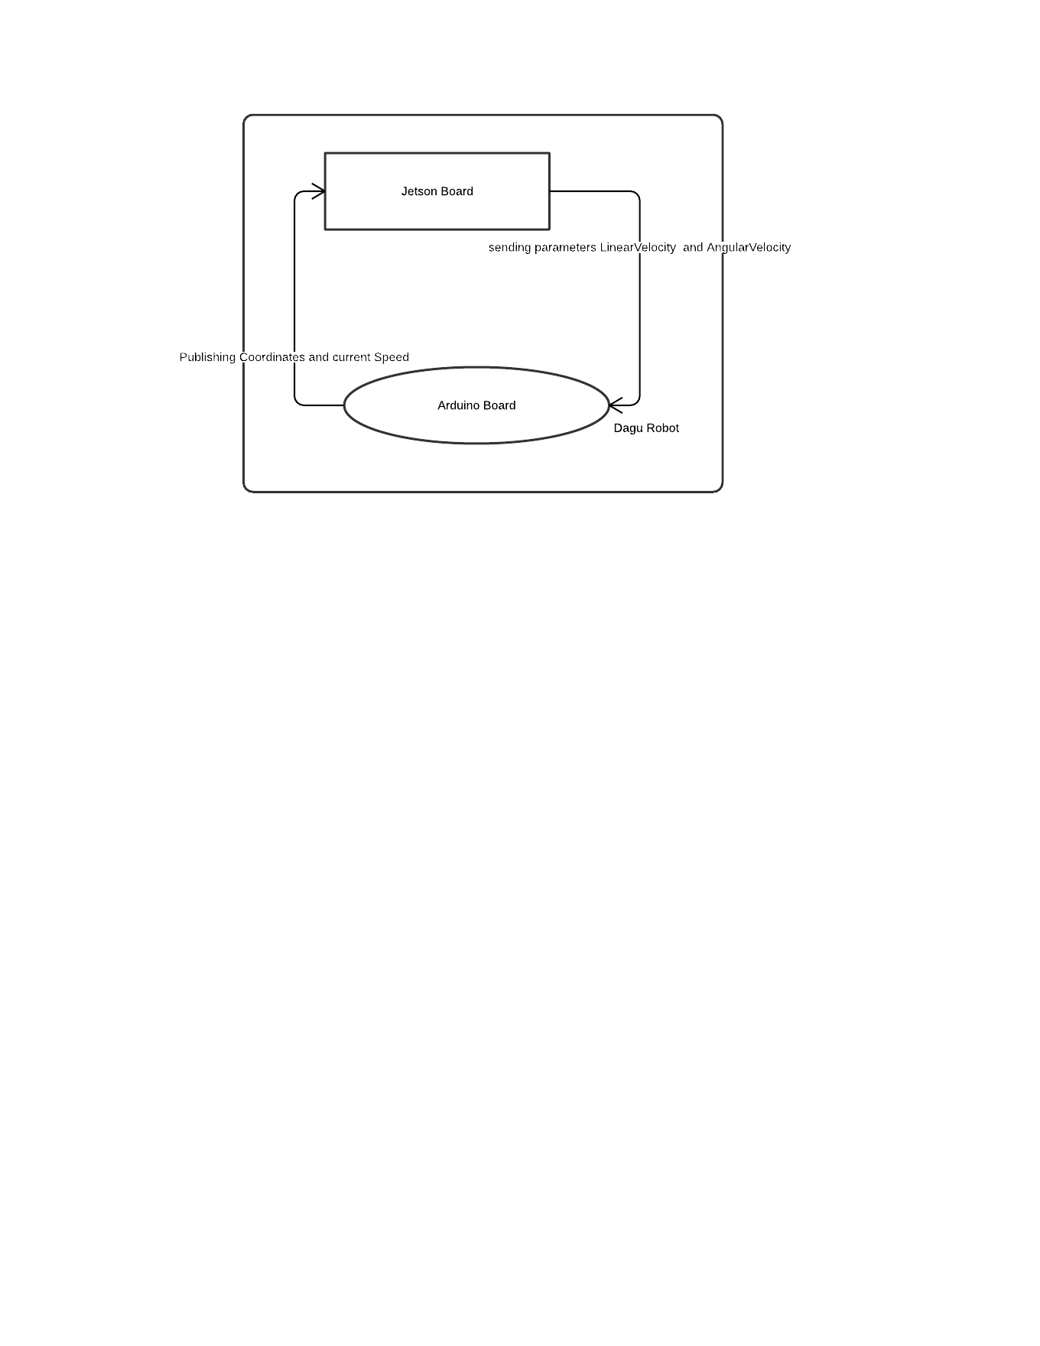

Figure ‑ Feedback loop occurs between the Jetson board and the Arduino board, removing the need for PID control on the Arduino

The Jetson Board runs all other subsystems mentioned earlier with the exception of the path planning subsystem. Also the camera is attached to the Jetson board. The Jetson board is battery powered, and also powers the Arduino microcontroller via USB.

### Motor Driver Board

The Motor Driver Board is powered by the Arduino Board. Its main role is to interface the Arduino board to the four motors of the car. After being powered by the Arduino board, it provides the motors with needed current to start moving the car around. The Arduino could not be directly facing the motors or otherwise it would have had to provide too much current than it originally can which would burn the board. Also, the two wheel encoders are connected to the Driver Board in which case the Motor Driver is also the interface between the Encoder sensors and the Arduino.

### Calculating Left and Right Distances

We will be discussing briefly how do we calculate the Left and Right Distances as well as how do we get the coordinates of the current car relative to its starting point. The mapping function will be discussed directly afterwards as well as the way we decided to turn the Dagu car to get the sharpest degrees possible. It is worth noting that the Dagu car is able to turn only by using the different wheel velocities since it is a differential wheel drive. However, the sharpest turns needed some more modifications. Additionally, throughout this section, right and left sides each refer to the two motors on their respective side.

#### Distance and Coordinates

Wheel Encoders eventually provide ticks. Usually the number of ticks depends on the encoder resolution. In our case, there were 16 ticks per revolution.   
The calculation of the distance travelled was therefore possible by only using the wheel encoders by knowing that each 16th tick is a complete revolution. Now given that, the circumference of the wheel multiplied by the number of ticks divided by 16 is travelled distance, as shown in equation 3-1.

|  |  |
| --- | --- |
| $$D=2πr*(ticks/16)$$ | (3-1) |

The same equation applies for both the left encoder and the right encoder, then an average distance is calculated accordingly. Using the calculated distance *X, Y* and $Θ$ can be calculated using the following set of equations,

|  |  |
| --- | --- |
| $$x=x+avgD* cos(Θ)$$ | (3-2) |
| $$y=y+avgD* sin\left(Θ\right)$$ | (3-3) |
| $$Θ=(R-L )/Lcar$$ | (3-4) |

where $avgD$ is the calculated average distance of the right distance and left distances of the two encoders. $R$ and $L$ in the equation are the right and left distances respectively and $Lcar$ is the distance between the front wheels of the Dagu car. For further explanation, please refer to the background section where there is the explanation behind the equations used. Given the specific Dagu car we used, the parameters are $Lcar$ = 0.315 m and $R$ = 0.063 m.

### Publishing Linear Velocity and Angular Velocity

Linear and angular velocities were calculated using the coordinates given along with the time value provided at that instance. The time was calculated by an internal function of the Arduino that is hardwired within the Atmega32 microcontroller of the Arduino. It isn’t a software function. The velocities are being calculated and published every half a second according to this function. The equations used in this part are:

|  |  |
| --- | --- |
| $$VelocityR=\frac{TotalDistanceR-HoldDistanceR}{timeDifference}$$ | (3-5) |
| $$VelocityL=\frac{TotalDistanceL-HoldDistanceL}{timeDifference}$$ | (3-6) |

$HoldDistanceR$ and $HoldDistanceL$ are the distances caught at a certain point in time and $TotalDistanceR$ and $TotalDistanceL$ are the distances caught at 0.5 seconds afterwards. Hence $TotalDistance$– $HoldDistance$*= Δdistance* in 0.5 seconds. The value 0.5 seconds is a value chosen not to be too small to avoid very small value and round off errors and at the same time not very big to avoid error accumulation of the ticks of the time function. *TotalDistanceR* and *TotalDistanceL* are calculated by the accumulation of previously calculated *DistanceR* and *DistanceL* respectively.

### Linear Velocity and Angular Velocity

Given Linear Velocity and the Angular Velocity, Left and Right velocities were calculated as follows:

|  |  |
| --- | --- |
| $$Vleft=LinearV-\left(\frac{AngularV*Lcar}{2}\right)$$ | (3-7) |
| $$Vright=LinearV+\left(\frac{AngularV*Lcar}{2}\right)$$ | (3-8) |

Please refer to background section 2.1 for a further detailed explanation regarding the above equations, and how they are derived from the assumed differential-drive kinematic model of the robot.

### Mapping the Velocities

In order to map the Left and Right velocities to motor speed some calculations we made. First, we had to get the range of velocities that the car could achieve. In our case, the car velocities range was 0.235 m/sec (Please notice that is a function of the voltage/current or battery provided to the car)

We subsequently had to get the different speed levels provided to the motor in terms of a pulse-width modulated output on the microcontroller. These speed levels differ according to the minimum speed at which the car would start moving. The maximum speed is given by the max number that can be achieved by an unsigned byte which is 255. The different possible speed levels in this case were 255 – minimumLevel = 255 – 90 = 165 since any value lower than 90 on the pulse-width modulated output were insufficient to drive the motor (these values are specific to our set-up i.e. battery, etc.).

Now both ranges can be used to map the coming speed to one of the available levels of speed according to the below equations. The values calculated can be used as inputs directly to the motor.

|  |  |
| --- | --- |
| $$DifferenceL=Vleft-minV$$ | (3-9) |
| $$DifferenceR=Vright-minV$$ | (3-10) |
| $$speedL=round\left(\frac{DifferenceL*SpeedLevels}{rangeV}\right)+90$$ | (3-11) |
| $$speedR=round\left(\frac{diffrenceR*SpeedLevels}{rangeV}\right)+90$$ | (3-12) |

#### Dagu Robot Sharp Turns

Since linear and angular velocities were able to be converted into left and right velocities for each side of the robot, it was able to turn. However, there was a minimum angle on which it could turn as long as all the motors directions where the same.

Therefore, we have used the ability of controlling the motor direction and have used it, while the robot is stationary but turning in place, to get the minimum/sharpest angle possible. For instance, in order for the robot to turn right, the left side wheels would be moving forward, whereas the right side wheels moving backward. That had allowed us to turn in place using the best/sharp angles. Also turning the motors into opposite directions had allowed us to pass to our code on the Arduino board negative parameters as negative linear and angular velocities since they can then be translated as opposite motor direction with the same speed.

## Path Planning Subsystem

The path planning subsystem is responsible for the autonomous navigation of the robot. At anytime the robot is given a goal and the path planning subsystem sends a sequence of velocity commands that directs the robot towards the goal safely without bumping into any obstacles. ROS facilitates the path planning procedure by providing a node called “move_base” [31].

### Move Base Overview

The move base node facilitates the path planning process by running other 5 nodes that work together to plan a path and send commands to the robot. The move base node is subscribed to certain topics to receive the required data from the other subsystems in the navigation stack. It also publishes the velocity commands to a topic that can be received by the robot controller to be executed. These topics are shown in Figure 3-7, and discussed in more detail in the following sections.

move_base

**map**

**tf**

**odom**

**cmd_vel**

Figure ‑ move_base topics

## 

#### Move Base Subscribed Topics

The following are topics that the path planning subsystem is subscribed to to receive the necessary data:

* **map** - The map topic provides a 2d occupancy grid. Cells of the map can be free, occupied or undiscovered.
* **tf** - The tf topic provides a tree of transformations of different frames in the environment. For example, it describes the location of the sensors relative to the center of the car.
* **odom** - The odom topic provides the current location and the velocities of the robot.

#### Move Base published topics

Move base publishes only one topic which is cmd_vel. That is a topic that provides linear and angular velocity commands. The base controller of the car can subscribe to that topic to receive the commands to get executed.

#### Move Base nodes

The following are the 5 nodes that move base runs:

* **global_planner** - provides a least cost path given a global cost map and a goal.
* **Local_planner** - provides velocity commands given a global path and a local cost map.
* **global_costmap** - provides a cost map to the global planner.
* **local_costmap** - provides a local cost map to the local planner.
* **recovery_behaviors** - undergoes some emergency behavior if the robot is stuck or oscillates.

### Global Planning

Global planning plans a global path for the robot to follow. It requires a global cost map of the environment, the robot’s current coordinates and orientation and the coordinates and orientation of a goal. Anytime Dynamic A* algorithm known as AD* was used as the planning algorithm in a lattice planning environment.

#### Global Cost Map

For the global planner to provide a valid map it uses a cost map to identify the location of obstacles and free space. ROS has a node called “costmap_2d” [32] that updates cost cells from the map provided by SLAM subsystem. Obstacles are allowed to get inflated as a safety measure so that the planned path would be away from the obstacle by a safety margin. The following are important parameters that have to be configured:

* **inflation_radius** - The radius by which the obstacles get inflated.
* **Cost_scaling_factor** - The exponential decay factor by which cost is given to cells away from obstacles.
* **Update_frequency** - The frequency at which the cost map updates cost values based on changes in the map provided by SLAM and the laser scan data.

#### Graph Representation

The problem has to be represented as a graph structure before using a graph search algorithm. There are two general methods to represent the environment as a graph. In the first method, the nodes represent grid cells and edges represent the cost of going from one cell to the other. In the second method, the nodes specify the different states the robot can go to from its current state and the edges represent the cost of going from one state to another. The latter method was chosen for two reasons. First, it decreases the number of nodes in the graph compared to a high density grid map. Second, it allows to give different costs for different kinds of motions. Figure 3-8 [33] shows this kind of graph representation when incorporated with a cost map.



Figure ‑ Lattice planning environment

A MATLAB script that is provided by the search-based planning lab (SBPL) [34][37] has been used to generate a motion primitive file for our robot. This file defines that different states the robot can go to from its location and that is shown in figure 3-9. Direct forward and backward states are given less cost than other states to minimize steering and rotations in the robot’s movement.



Figure ‑ Robot motion states

### AD* Planning Algorithm

AD* is a deterministic graph search algorithm that can find the least cost path. It is very fast in providing suboptimal solutions and it can reach the optimum solution through a successive iterations of improvements. It is also a dynamic algorithm that can efficiently adapt planned paths to changes in the environment without planning from scratch. The SBPL Lattice Planner library [36] provided by search-based planning lab was used and integrated in ROS to implement the AD* algorithm. The following are important parameters that need to be configured:

* **initial_epsilon** - Increasing this parameter allows a faster solution to be provided but of less quality.
* **allocated_time** - It is the time after which the suboptimal solution is used if no optimal solution is provided.

### Local Planning

A local planner is needed to send velocity commands to the controller given a global path and a cost map of the environment. A global path is practically not enough because the robot usually deviates from the planned path so there should be another controller that realigns the robot again to the correct path. Trajectory rollout algorithm is used for the local planner.

#### Local Cost Map

Local planning requires its own cost map in order for it to make decisions relating to local obstacle avoidance and short-term drift correction. The local cost map is a non static cost map, which has a predefined dimensions and is centred around the robot’s current position [5]. In the local cost map each cell has 3 cost values corresponding to the following factors:

* **Global path** - Cells on the global path are given a value of zero. A propagation algorithm is used to score other cells based on their distance to the nearest zero.
* **Local Goal** - The endpoint of the global path within the local cost map is defined as the local goal and is given a zero cost value. Other cells are given cost values according to the distance to the local goal.
* **Obstacles** - Cells that are occupied are given high cost values. If obstacles inflation is used, cells that are near to obstacles are also given cost values.

Important parameters that need to be configured:

* **Update_frequency** - The frequency at which the local cost map gets updated.
* **Width** - The width of the local cost map in meters.
* **Height** - The height of the local cost map in meters.

#### Trajectory Rollout

Trajectory rollout is a sampling based method that is used to score trajectories for different linear and angular velocities. ROS navigation package has a library that implements several local planning algorithms [36], Trajectory Rollout is one of them.

The way the algorithm works is by sampling from the range of linear and angular velocities. A trajectory is simulated for the sampled linear and angular velocity. The trajectory is then scored as a weighted average cost based on how far the trajectory is to global path, local goal and obstacles. The least cost trajectory is chosen and the corresponding sampled linear and angular velocities are passed to the base controller. This is illustrated in Figure 3-10.

Sample from control space

Simulate trajectories

Score trajectories

Pick highest score trajectory

Figure ‑ Trajectory rollout planner

The following are important parameters for the local planner algorithm, all of which must be configured for our robot for successful path planning operation:

* **max_vel_x** - The maximum linear velocity of the robot.
* **min_vel_x** - The minimum linear velocity of the robot.
* **max_vel_theta** - The maximum angular velocity of the robot.
* **min_vel_theta** - The minimum angular velocity of the robot.
* **Sim_time** - The time for which a trajectory is simulated.
* **vx_sample** - Number of linear velocities to sample when exploring possible trajectories.
* **vtheta_samples** - Number of angular velocities to sample when exploring possible trajectories.
* **gdist_scale** - The weighting for how much the controller should attempt to reach its local goal.
* **pdist_scale** - The weighting for how much the controller should stay close to the global path
* **occdist_scale** - The weighting for how much the controller should attempt to avoid obstacles

## SLAM Subsystem

For the purpose of generating 2D grid maps, it was decided that a particle filter method would be most appropriate. This choice was made for two primary reasons:

* They have asymptotically better running time than Kalman filter based techniques, and their larger memory requirements are still manageable in the context of two dimensional grid maps.
* They can be made in such a way that they directly output a grid map, while Kalman filter and least-squares approaches generally map using landmarks.

For the purpose of localization and mapping, ROS has numerous open-source packages with highly efficient implementations of well-known SLAM algorithms. The relevant one for our purposes is the gmapping package, which implements a Rao-Blackwellized particle filter to generate 2D occupancy grid maps using laser range data [38]. One issue we have is that we do not in fact use a laser scanner. However, by use of other packages which are described in Section 2.6, we produced “fake” laser range data. Figure 3-11 shows a view of the gmapping package in the context of the system. It is essentially the core of the system, in that it is the only subsystem that interfaces with all of the other subsystems.

The gmapping package subscribes to the sensor topic, which is meant to have laser scan messages, and it also subscribes to the odom topic, which is meant to have pose estimates published by the robot via its odometry system. Taking these two topics, the gmapping package outputs an occupancy grid map using the Rao-Blackwellized particle filter internally. Rather than publishing a pose estimate for the robot, the gmapping package instead published a coordinate frame transform between the map and the robot, in such a way as to realign the map so that the robot’s odometry estimate is in the correct point on the map. The notion of coordinate frame transformations will be discussed in greater detail in chapter 3.7.

sensor source

gmapping

move_base

**sensor**

**map**

**odom**

base controller + odometry source

Figure ‑ The gmapping package is in the center of the stack and communicates with numerous subsystems

The Rao-Blackwellized particle filter is a complex algorithm and therefore cannot be used successfully if treated as a black box. The gmapping package has numerous configurable parameters to tune the particle filter to different robots, sensor models and mapping requirements. There are a total of 37 configurable parameters, some of which are constants pertaining to the specifications of the robot and sensors, while others are related to the inner workings of the algorithm. Below are some of the most important parameters for our purposes:

* **map_update_interval** – the number of seconds between map updates.
* **maxUrange** – the maximum usable range of the sensor
* **iterations** – the number iterations for scan matching
* **lsigma** – the uncertainty in the sensor’s distance measurements
* **srr, srt, str, stt** – uncertainty in the robot’s motion
* **linearUpdate, angularUpdate** – linear or angular changes that need to occur in the robot’s pose before another sensor measurement is taken
* **resampleThreshold** – the average likelihood value of the current set of particles below which the particle filter decides to resample the set
* **particles** – the number of particles maintained to estimate the map
* **occ_thresh** – the likelihood value of a cell in the grid map being occupied, above which it will be considered occupied
* **delta** – the resolution of the grid map

Robot motion and sensor specific parameters such as “maxUrange”, “lsigma” and “srr” are determined by running experiments to measure them. For example, the “maxUrange” parameter can be determined by monitoring the output of the depth sensor while placing an object directly in its line of sight. The object is then moved further away from the sensor, until it is no longer registered by the sensor, and this distance is taken as the maximum usable range. Similarly, the robot’s motion uncertainty can be quantified by moving the robot in straight lines and physically measuring its trajectory, and comparing it to what it reports through odometry. Other parameters that are more related to the inner working of the particle filter, such as “resampleThreshold” and “particles” are determined experimentally through a process of trial and error. The robot is remote controlled around an area, while generating maps. We vary the parameters until we find a configuration that produces more accurate maps.

## Depth Sensing Subsystem

The implementation of visual odometry module on the robot was a long process that required a lot of interface matching specially due to the lack of hardware support for many of the state of the art cameras on embedded systems. As mentioned in the system overview, the implementation of visual odometry module took place on Jetson TK1 NVIDIA board after going through a long process of selection. In this section, we are going to discuss the process of hardware selection, connection, interface and how sensor data are collected and manipulated to be used in SLAM algorithms later on.

### Sensor Peripherals

To implement visual odometry in a robust manner the decision of selecting a depth camera was made. Depth Cameras allowed us to use appearance based methods including pixel by pixel analysis which provides more accurate pose estimation of the robot and providing odometry data for Localization and Mapping module. Figure 3-12 shows the options for depth sensor devices:

|  |  |  |
| --- | --- | --- |
| **Sofkinetic DS325** | **Kinect for Xbox 360** | **Kinect for Xbox One** |
|  |  |  |

Figure ‑ Various low-cost RGB-D cameras

The initial decision was to use Kinect for Xbox 360 which was already available for the group as a gaming console peripheral. Nevertheless, the USB cable that connected the device to the laptop for development purposes was not available locally. The second choice was to use Kinect for Xbox One which was also unavailable locally and came with a cable for development but on Windows. This posed two challenges, namely the need to wait for the device and cable to ship and second the need to use the need to have an embedded board with Windows 10 for embedded systems installed on it. Finally, the choice was to use Softkinetic DS325 [39] which was also available for the group and had Software Development Kit [40] publicly reusable on Linux.

Soft Kinetic is a CMOS 3D camera with time-of-flight depth estimation technique. Its main usage in the market is directed at gesture recognition with precision reaching the level of knuckle and finger tracking. Figure 3-13 shows the main components of the camera.

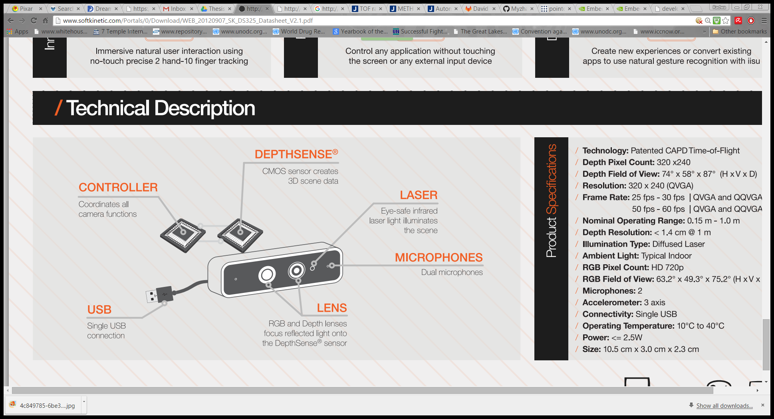

Figure ‑ Main components of the SoftKinetic DS325 [39]

Table 3-4 lists the technical specifications of the camera.

Table ‑ SoftKinetic DS325 Specifications

|  |  |
| --- | --- |
| **Product Specifications** | |
| Technology | Depth CAPD Time Of Flight Technology (patented) |
| Depth Pixel Count | 320 x 240 |
| Depth Field of View | 72o x 58o x 87o (HxVxD) |
| Resolution | 320 x 240 QVGA & QQVGA |
| Frame Rate | 25fps-50fps (QVGA)  30fps-60fps (QQVGA) |
| Normal Operating Range | 0.15m-1.0m |
| Illumination Type | Diffused Laser |
| Depth Resolution | <1.4cm @ 1m |
| RGB Pixel Count | HD 720p |
| RGB Field of View | 63.2o x 49.3o x 75.2o (HxVxD) |
| Connection | Single USB |
| Accelerometer | 3 Axis |
| Microphones | 2 |
| Power | <=2.5W |
| Size | 10.5cm x 3.0 cm x 2.3 cm |

Their patented approach towards creating a quick TOF measurement technique is done using radiation and modulation. The method includes emitting modulated radiation in response to a first modulation signal. Like any other TOF sensor, the method starts by projecting radiation onto a scene and then receiving the reflected radiation of the obstacles in the scenery. The received radiation is then transformed into a radiation induced electrical signal which is mixed with a second modulation signal, thus generating a mixed signal, which is integrated, thus generating an integrated signal as shown in Figure 3-14.

Scene

Radiation

Modulated Radiation

Sensor

Radiation Induced Electric Signal

Second Modulation Signal

Modulated Output Signal

Figure ‑ SoftKinetic process for quick TOF measurements

The method requires changing the first and/or second modulation signal at one or more moments in time, and measuring the integrated signal at one or more moments in time, thus obtaining at least one TOF pair difference signal. The measuring includes using a single detector node and associated memory element, e.g. capacitor, to obtain a TOF pair difference signal. Obtaining a TOF pair difference signal may include changing the polarity sign of the integrated signal by changing polarity of the integrating capacitor synchronized with the moments in time at which changes to the first and/or second modulation signal are applied. This way, in-pixel subtraction of TOF pair signals is performed.

### Computation Board

Our first selection was Raspberry Pi 2.0 (B+) which has an ARM 7 Processor and Raspbian OS. We started our development on this board; nevertheless, the SoftKinetic SDK for embedded Linux System had a lot of problems with Raspbian OS including its USB drivers and its version of c-library specifically ***glibc*** version. We hence resorted to using the more powerful NVidia Jetson TK1 board with Linux Ubuntu 14.04 for Tegra shown in Figure 3-15 [41].

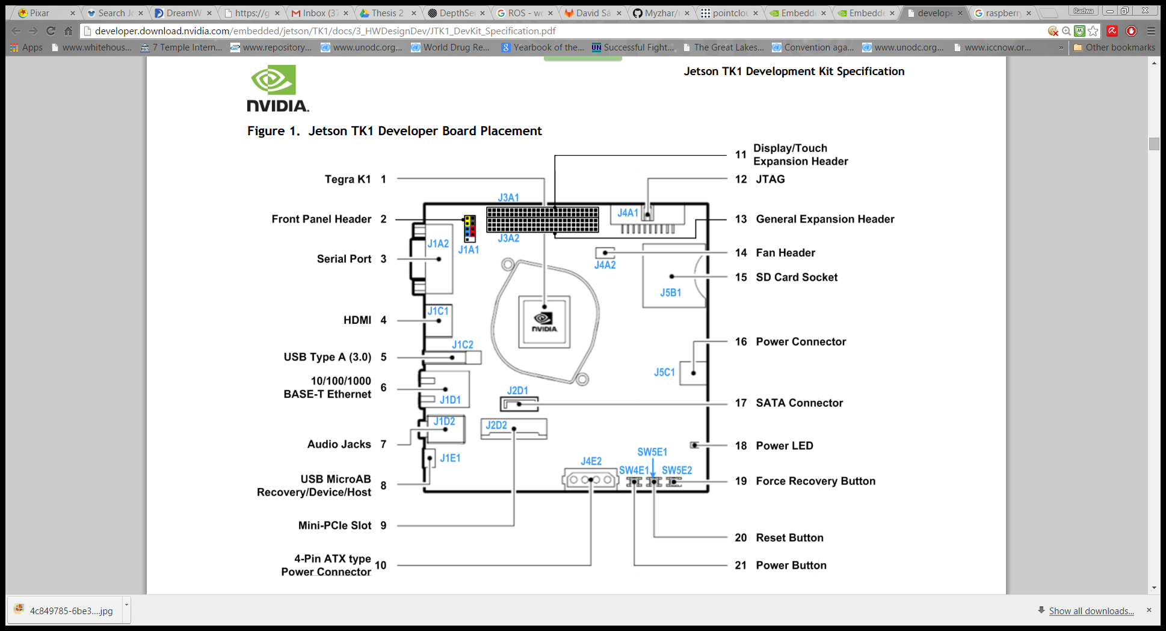

Figure ‑ Schematic of the NVidia Jetson TK1 board

Table 3-5 [42] lists the specifications of the NVidia Jetson TK1 board.

Table ‑ NVidia Jetson TK1 specifications

|  |  |
| --- | --- |
| Product Specifications | |
| Tegra Processor | Tegra K1 SOC  NVIDIA Kepler GPU with 192 CUDA Cores  NVIDIA 4-Plus-1™ Quad-Core  ARM® Cortex™-A15 CPU |
| Memory | 2 GB x16 Memory with 64-bit Width  16 GB 4.51 eMMC Memory |

### ROS Depthsense Camera

This ROS package makes use of the SoftKinetic SDK for Arm-Cortex v7 available in the Tegra board [43]. It creates a ROS node that basically contains 10 event handlers required to run the minimal functionalities of SoftKinetic Sensor. Figure 3-16 shows the class diagram of the node.

*main ()

Depthsense_camera_node

* void onDeviceAdded (DepthSense::Context context, DepthSense::Device device);
* void onDeviceRemoved (DepthSense::Context context, DepthSense::Device device);
* void onNodeAdded (DepthSense::Device device, DepthSense::Node node);
* void onNodeRemoved (DepthSense::Device device, DepthSense::Node node);
* bool addDepthNode (DepthSense::Device device, DepthSense::Node node, int32_t& width, int32_t& height , float& range);
* bool addColorNode (DepthSense::Device device, DepthSense::Node node, int32_t& width, int32_t& height );
* bool addAudioNode (DepthSense::Device device, DepthSense::Node node);
* void onNewDepthNodeSampleReceived (DepthSense::DepthNode node, DepthSense::DepthNode::NewSampleReceivedData data)
* void onNewColorNodeSampleReceived (DepthSense::ColorNode node, DepthSense::ColorNode::NewSampleReceivedData data);

Depthsense_camera_driver

Figure ‑ Class diagram of the ros_depthsense_camera node

The SDK for SoftKinetic [40] provides two methods of streaming the depth data from the camera in the following modes:

* Client Server Mode: $DepthSense::Context::createStandalone();$
* Standalone Mode: $DepthSense::Context::createStandalone();$

For embedded systems one can only use standalone mode because the client server model is not supported by embedded platforms. This ROS Node can handle up to 60 connected devices [43][44]. It initializes the devices and nodes related to each device where every node publishes two main ROS Topics:

* vertex_data :: sensor_msgs/PointCloud2 topic
* rgb_image :: sensor_msgs/Image topic

This means that this node converts the raw data from the sensor to published topics that can be accesses by other nodes in ROS and these topics are of types sensor_msgs/PointCloud2 (Point Cloud 2 Documentation, 2015) and sensor_msgs/Image topic. The frames were set at rate 60fps but were cut down to rate 30fps to be able to fully communicate the data over Wi-Fi to SLAM. To further cut on bandwidth usage, SoftKinetic also supports Long Range Mode of 6Hz [44] while maintaining good data quality. This provides up to 4.0m of range which helps facilitate the mapping process.

One problem with this package is that the feed of the camera was usually rotated with 90o from what was expected by the SLAM. This package provided the feed of the camera into a rotated frame as well. Hence the generated map was incorrect [43][44]. That’s why we had to omit the dynamic transfer provided in the package by removing it from inside the package and adding a static transform in our launch file as follows:

<node pkg="tf" type="static_transform_publisher" name="depth_to_base_link" args="0 0 0.3 0 0 1.57079 /base_link /depth_frame 200"/>

<node pkg="tf" type="static_transform_publisher" name="rgbd_to_base_link" args="0 0 0.3 -1.57079 0 -1.57079 /base_link /rgb_frame 200"/>

Figure ‑ Static transforms of camera coordinate frames

X

Y

Z

X'

Y’

Z’

X’’

Y’’

Z’’

Base Link Frame

Depth Frame

RGB Frame

Figure ‑ Coordinate frames of the camera with respect to base link frame

Hence this relates the frame of the Depthsense camera to the frame of base_link odometry with a z-shift of 0.3 meters and a rotation of 90 degrees in roll direction (rotation around z-axis). The RGB frame is also shifted 0.3 meters upwards and rotated -90 degrees in yaw direction (rotation around x-axis) and -90 degrees in roll direction as shown in figure 3-18.

### Pointcloud_to_laserscan

This package converts a 3D Point Cloud into a 2D laser scan [46]. This is useful for making devices like the Kinect appear like a laser scanner for 2D-based algorithms (e.g. laser-based SLAM). The package used for SLAM algorithm assumes it has a 2D scan from a laser scanner that’s why a conversion from point cloud topic to laser scan topic is needed.

This ROS Node subscribes to one topic, generically called:

* cloud_in :: sensor_msgs/PointCloud2 topic (we had to match it to the output topic from the previous Node which is vertex_data)

It publishes one topic called:

* scan :: sensor_msgs/LaserScan topic

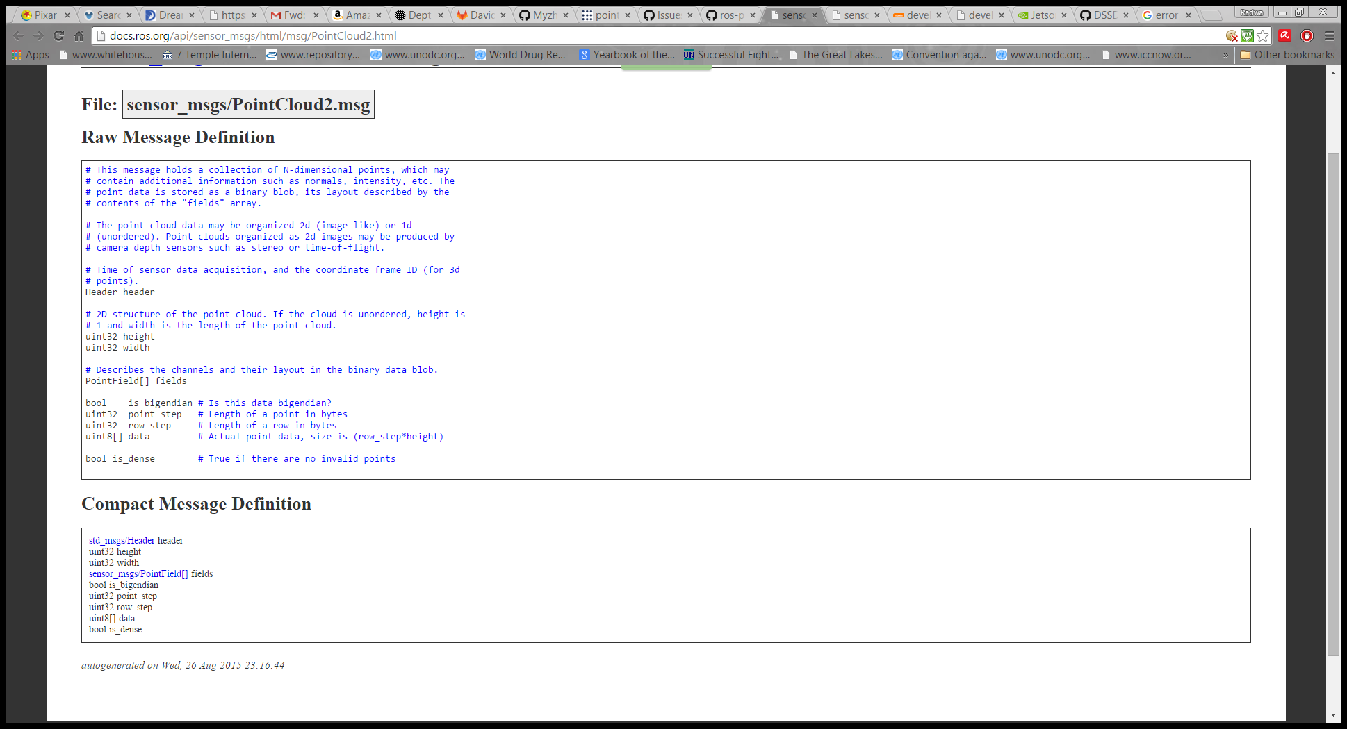

Figure ‑ Data Structure of sensor_msgs/Pointcloud2 [45]

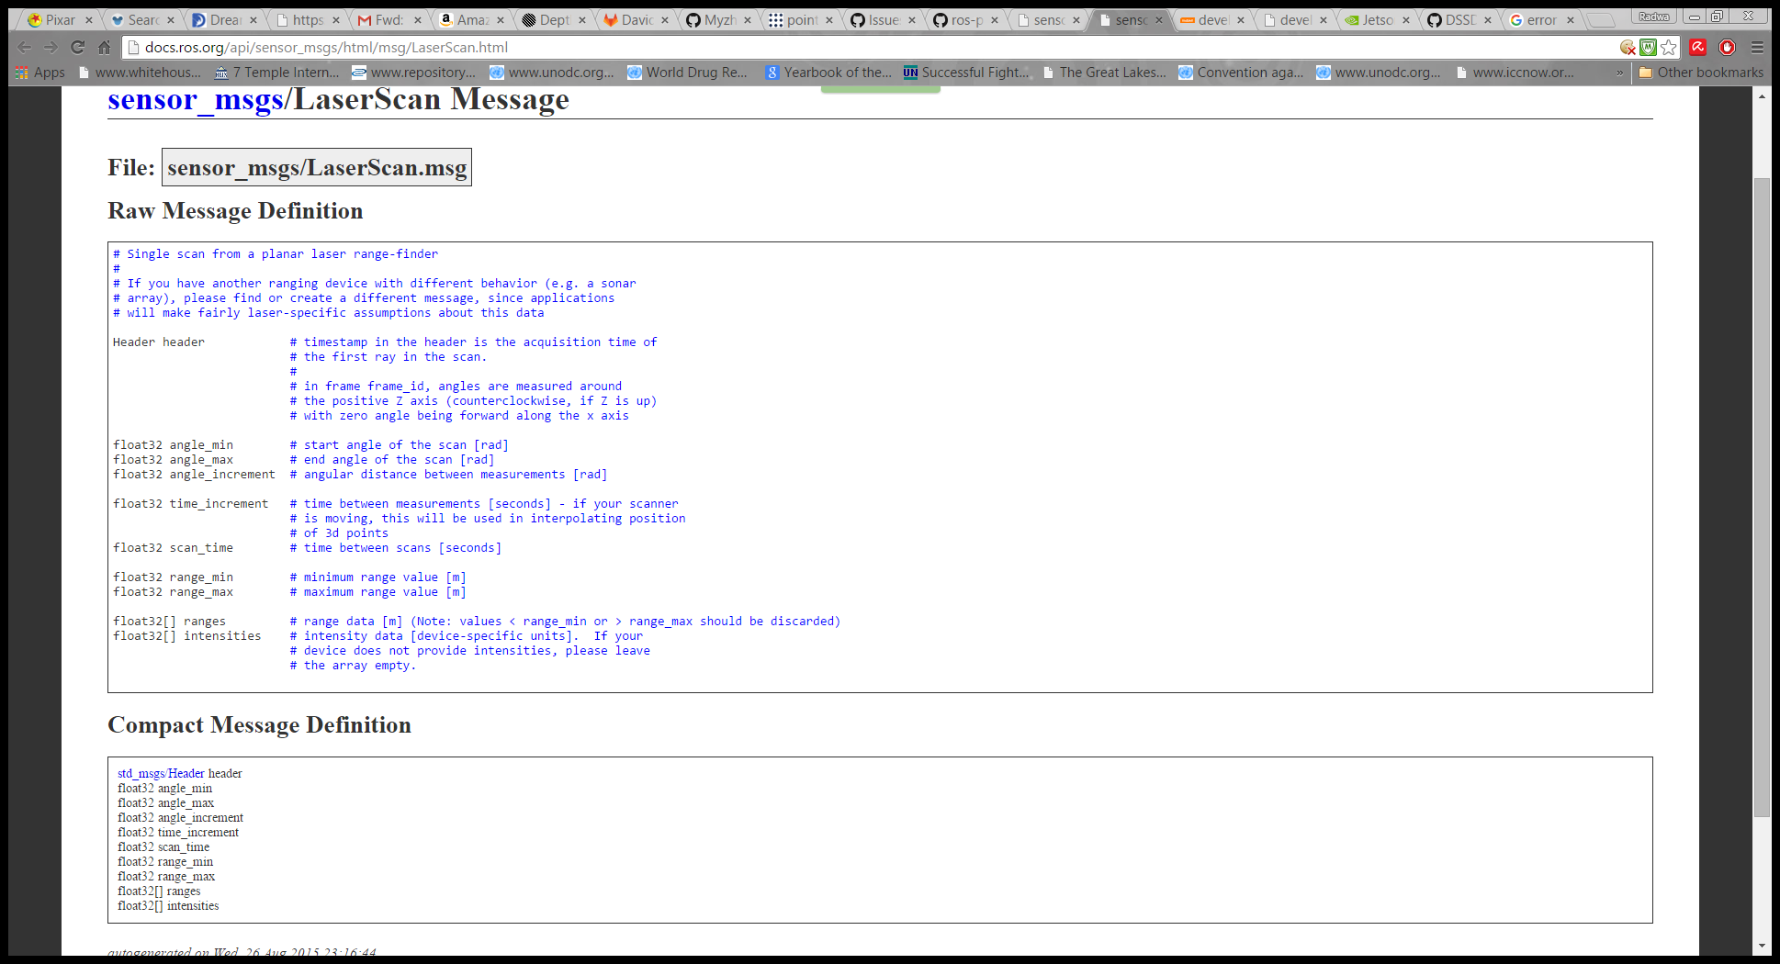

Figure ‑ Data Structure of sensor_msgs/LaserScan [47]

From the node ROS_DEPTHSENSE_CAMERA the attributes of the PointCloud2 Message are set. Figure 3-19 shows the structure of the message and Table 3-6 shows how it was populated in the module. A consistent header to be sent with all messages is first created and set to the following values:

Table ‑ Header of vertex_data message [44] [45]

|  |  |
| --- | --- |
| **Time Stamp** *(_lastPtCloudMsgHeader.stamp*) | Current Time (*ros::Time::now()*) |
| **Sequence** *(_lastPtCloudMsgHeader.seq)* | Total Number of Samples *(Info->totalSampleCount)* |
| **Frame Name** *(_lastPtCloudMsgHeader.frame_id)* | Coordinate Frame Designated Name *("depth_frame")* |

The rest of the attributes are also set every message sent as follows (Data are represented as 2D array):

Table ‑ Content of vertex_data message [44] [45]

|  |  |
| --- | --- |
| **Height of 2D array of Data** (*cloud_msg->height* ) | Height (*info->height)* |
| **Width of 2D array of Data** *(cloud_msg->width* *)* | Width *(info->width)* |
| **Density of Point Cloud** *(cloud_msg->is_dense)* | Sparse *(false)* |
| **Data Standards** *(cloud_msg->is_bigendian)* | Little Endian *(false)* |

Then an iteration over the XYZ coordinates of the Point Cloud are sent sequentially in that order. The scan message on the other hand is produced in Pointcloud_to_Laserscan Node and it has the following fields being set as follows:

|  |  |
| --- | --- |
| **Header** (*output->header* ) | Same as header of Point Cloud (*cloud_msg->header)* |
| **Target Frame [in header]** *(output.header.frame_id)* | Same as that of Point Cloud or I/P Parameter (*target_frame_)* |

Table ‑ Header of scan message [46] [47]

It then starts setting the parameters it has in the XML File. Parameter tuning is extensively discussed in chapter 4. The list of parameters are as follows [48]:

* **min_height** (*double, default: 0.0*) - The minimum height to sample in the point cloud in meters.
* **max_height** (*double, default: 1.0*) - The maximum height to sample in the point cloud in meters.
* **angle_min** (*double, default: -π/2*) - The minimum scan angle in radians.
* **angle_max** (*double, default: π/2*) - The maximum scan angle in radians.
* **angle_increment** (*double, default: π/360*) - Resolution of laser scan in radians per ray.
* **scan_time** (*double, default: 1.0/30.0*) - The scan rate in seconds.
* **range_min** (*double, default: 0.45*) - The minimum ranges to return in meters.
* **range_max** (*double, default: 4.0*) - The maximum ranges to return in meters.
* **target_frame** (*str, default: none*) - If provided, transform the pointcloud into this frame before converting to a laser scan. Otherwise, laser scan will be generated in the same frame as the input point cloud.
* **concurrency_level** (*int, default: 1*) - Number of threads to use for processing pointclouds. If 0, automatically detect number of cores and use the equivalent number of threads. If 2->+INF, set the input number as the parallelism level. Input queue size for pointclouds is tied to this parameter.
* **use_inf** *(Boolean, default: true) -* If disabled, report infinite range (no obstacle) as range_max + 1. Otherwise report infinite range as +INF.

The calculation of laser scan values is done as shown in Figure 3-21.

Figure ‑ Laser Scan range calculation

1. The $<x,y,z>$ values of every sample in the point cloud is extracted
2. It’s checked if its height falls within the range of heights specified by the parameters $range_{min}<Z<range_{max}$
3. Scan is then calculated using the following equation: $scan=\sqrt{x^{2}+y^{2}}$ the angle is also calculated as follows $angle=\tan^{-1}\left(y/x\right)$
4. A laser scan ray is then drawn with the following way:

 $int index ={(angle – output.angle_{min})}/{output.angle_{increment}}$

  2. Then Scan message content is checked if another ray exists with higher value $range < output.ranges[index]$
   3. Then the ray at this angle is updated with the smaller new value

## Additional Implementation Details

The following section outlines a number of additional considerations made in the implementation of the system necessary for the system to function correctly when integrating all of the subsystems.

### Inter-Platform Communication Links

As mentioned in the high-level description of the system, our implementation involves three separate platforms, each of which runs some of the subsystems. There are two communication links needed for the system to work, which are the following:

* Arduino – Jetson via USB serial communication
* Jetson – Computer via Wi-Fi communication

#### USB Serial Communication

In order for us to communicate over USB between the Arduino microcontroller and the Jetson board, we made use of a ROS node called rosserial, as well as loading ROS libraries on the Arduino microcontroller as a means for it to understand basic ROS methods. The data being transferred between the two systems however overloaded the Arduino’s serial buffer. As such, we modified the maximum allowable buffer size on the Arduino to 1024 bytes (as opposed to the default 256 bytes), while compensating for this by lowering the rate at which messages were published between the two platforms.

#### Wi-Fi Communication

To connect two separate computers (in our case, a laptop and the Jetson board) over a network in ROS, we connect both devices to a single Wi-Fi network and run ROS on both devices. We then take the IP address of the Jetson board along with a port number for ROS, and set it as a Linux environment variable called ROS_MASTER_URI on the computer. This makes the computer look for ROS on the Jetson board instead of locally. We also set an environment variable called ROS_IP as the local IP of each machine.

A subtle issue that arises is the need for time synchronization between the two machines. This is because ROS messages all have timestamps so that they can be processed correctly. For example, the gmapping package looks at the timestamps of the odometry messages published by the control system and matches them with timestamps on the laser scan data to match the two in time. The boards use their own local times, and so if they are not in sync, then ROS will fail to match data coming from different sources. The issue of time synchronization is easily dealt with by using Internet servers to set the time on both machines.

### Power Supplies

Two separate power supplies were needed for the system. The first powered the car motors. This was done using a 6-volt lead-acid battery with a capacity of 4 ampere-hours. This was not connected directly to the motors, rather it was passed through a 4-channel DC motor driver capable of supplying up to 4 amperes (which is the stall current of our motors) on each of its output channels, while regulating the voltage to the desired level.

A second power supply was needed for the Jetson TK1 board, which in turn powered all of the USB peripherals to the Jetson board, such as the Arduino microcontroller and the SoftKinetic camera. For this, we needed a 12-volt supply, which was done using a simple rechargeable 11.1-volt lithium-ion battery connected via a 2.1mm male DC barrel plug to the Jetson board. Voltage regulation is done on the Jetson board. The battery used had a capacity of 2,200mAh, which translates into approximately 6 hours of battery life running the Jetson board.

### Coordinate Frame Transformations

In order to facilitate the development of complicated robotic systems, ROS uses an underlying data structure for the robot known as a transform tree (or a TF tree) [10]. The transform tree describes the relationship between all of the different coordinate frames on the robot. What this does is it allows for each subsystem to be designed independently of others, then when integrating systems, transformations are defined between the coordinate frames of all the subsystems, and ROS computes the transformations in real-time as the system is operating. For example, laser scan data is produced taking the camera as its origin. On the other hand, the control system which publishes odometry takes the robot’s center of rotation as its reference frame. Therefore, for the data to be consistent, a TF transform must be defined between these two references – in this case, a constant offset based on the robot’s dimensions. Our implementation had a number of different coordinate frames, with a transform tree as shown in Figure 3-22.



Figure ‑ Coordinate frames organised in a TF tree

Starting from the top of the tree, we have:

* **map** – this is the coordinate frame of the map produced by SLAM. Initially, the map frame and the odometry frame are identical. However, over time as the robot’s odometry estimate drifts, SLAM re-localizes itself by shifting the map frame with respect to the odometry frame, such that the odometry estimate is relocated in the map to the correct point.
* **odom** – this is the coordinate frame against which the robot estimates its coordinates. The robot initially begins at the origin and updates its coordinates with respect to this coordinate frame as it moves.
* **base_link –** this is a coordinate frame that always has its origin at the current location of the robot. It moves and rotates with the robot to achieve this.
* **depth_frame –** this is the coordinate frame from which depth data is acquired and has its origin at the location of the SoftKinetic camera.
* **rgb_frame –** this frame is not actually used by our system, however it is defined implicitly by the DepthSense camera should the user wish to view the camera’s video output.

The transformation from the map frame to the odometry frame is dealt with by gmapping. The base_link to odometry transformation is done by setting the offset between the two coordinate frames as the current coordinates of the robot’s pose estimate. Finally, the transformation from base_link to depth_frame is a constant offset, defined by an x translation and z translation describing the location of the camera on the robot relative to the robot’s center of rotation.

## Summary

In this chapter, we presented the system design at a high level and illustrated the interaction between subsystems. The actual implementation of the system using ROS’s message passing framework and standard messages was then explained, along with the platforms used in the implementation. Subsequently, the design of each individual subsystem was presented, including the hardware and software used for each subsystem, as well as the ROS node used to abstract that subsystem and integrate it in the ROS communication framework. We also provided a detailed account of some additional practical considerations such as power supplies and communication links.

# Experimental Results and Discussion

In this chapter, we present the final experimental results of our robot. We begin with an overview of the robot in terms of its layout and its cost, before proceeding to present various results obtained by the robot in path planning and mapping.

## Assembled Robot

The final assembled robot is shown in Figure 4-1

**SoftKinetic DepthSense Camera**

**Arduino Microcontroller**

**Jetson TK1 Board**

**Wi-Fi Dongle (Underneath)**

**DC Motor Drivers**

**Lead Acid Battery (Underneath)**

**Lithium Polymer Battery (Underneath)**

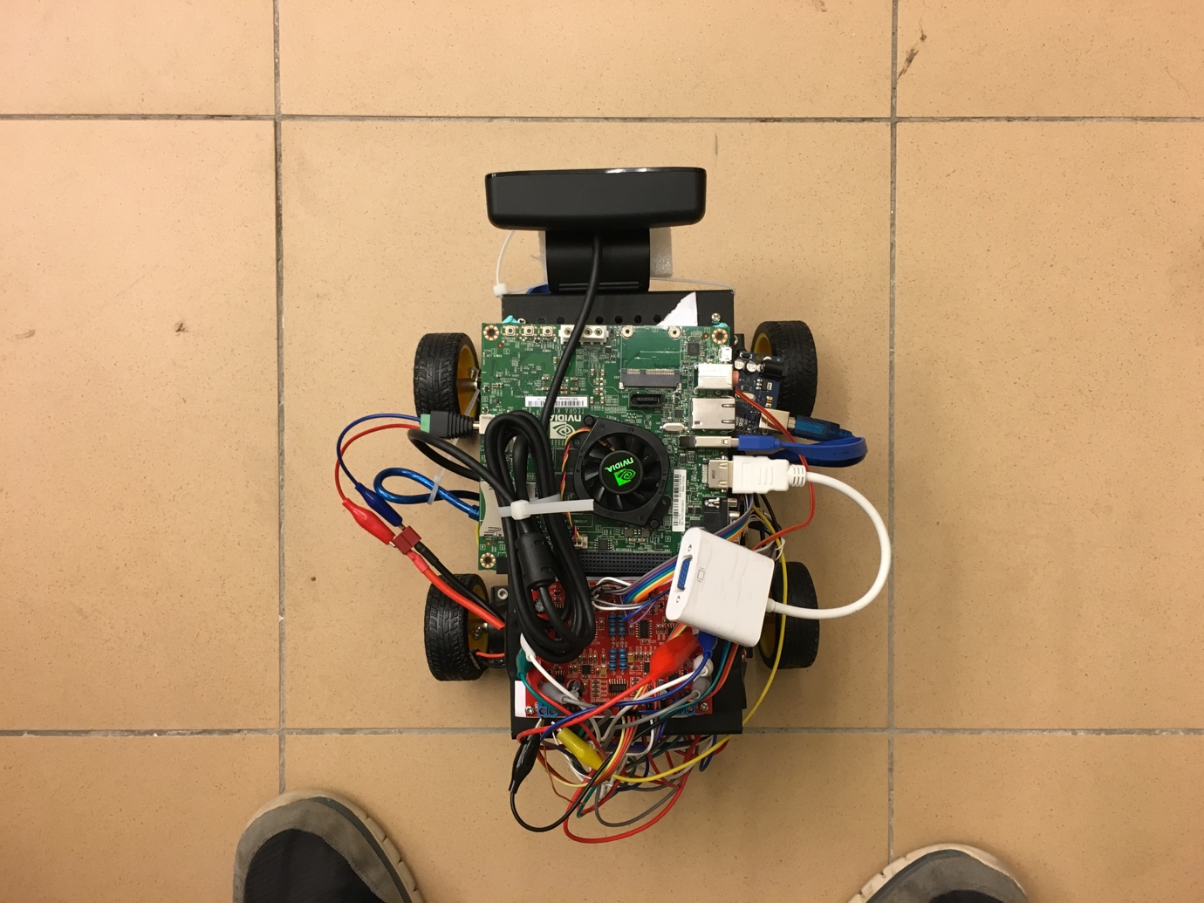

Figure ‑ Annotated picture of the final assembled robot

## System Cost

Since one of the primary objectives of the system was for it to be low-cost, we present a breakdown of the cost of all components in the system in Table 4-1. Some prices depend on the USD-EGP exchange rate. The listed prices assume an exchange rate of 1 EGP = 7.83 USD.

Table ‑ Breakdown of the cost of the system

|  |  |  |  |
| --- | --- | --- | --- |
| **Component** | **Price/Unit (EGP)** | **Number of Units** | **Total (EGP)** |
| Dagu Wild Thumper 4WD Car | 1,200.00 | 1 | 1,200.00 |
| NVidia Jetson TK1 | 1,502.52 | 1 | 1,502.52 |
| Arduino Mega 2560 | 350.00 | 1 | 350.00 |
| SoftKinetic DS325 | 1,565.12 | 1 | 1,565.12 |
| USB Wi-Fi Dongle | 95.00 | 1 | 95.00 |
| 6.5mm Robot Wheel | 22.50 | 4 | 90.00 |
| 4 Channel DC Motor Driver | 190.00 | 1 | 190.00 |
| Wheel Encoder | 70.00 | 2 | 140.00 |
| Lithium Polymer Battery 11.1V 2,200mAh | 215.00 | 1 | 215.00 |
| 2.1mm Male DC Barrel Plug | 6.00 | 1 | 6.00 |
| 6V 4Ah Lead Acid Battery | 30.00 | 1 | 30.00 |
| **Total** | | | 5,383.64 |

The total cost was greater than what was desired, primarily due to the substitution of the Raspberry Pi with the NVidia Jetson TK1, which added EGP 1,268.46 to the total cost. Nevertheless, the system is significantly cheaper than any laser scanner-based system, the cheapest of which use laser scanners which cost no less than USD 2,000 = EGP 15,660. There are numerous ways in which our system could potentially be made cheaper, which will be discussed in Chapter 5.

## Path Planning

There are many parameters that affect the performance of the path planning module. This section shows the effect of changing the most important parameters on the results. To be able to tune the parameters, a 2D simulator called “Stage” was used [49]. The simulator is given a description file that is used to simulate both the robot and the environment. In this section, we show how parameters affect the safety and quality of the planned path.

### Global Cost Map Inflation

A global cost map is constructed using the map data. The cost map inflates obstacles for safety. This cost map is used by the global planner to plan the global path. One of the most important parameters of the cost map is the inflation radius. It is necessary to choose a convenient inflation radius for the size of the robot and the type of the environment. Setting the inflation radius very low, can lead to planned global paths that are very near to obstacles and the robot may bump into them. Setting the inflation radius too high, will lead to unnecessarily longer planned paths. Figure 4-2 shows the case where radius of inflation is 5 cm as well as the case where the radius of inflation is 30 cm. It is shown that for only 5 cm for the radius of inflation, the planned path is very dangerous for the robot to follow. While 30 cm for the radius of inflation, is more convenient.

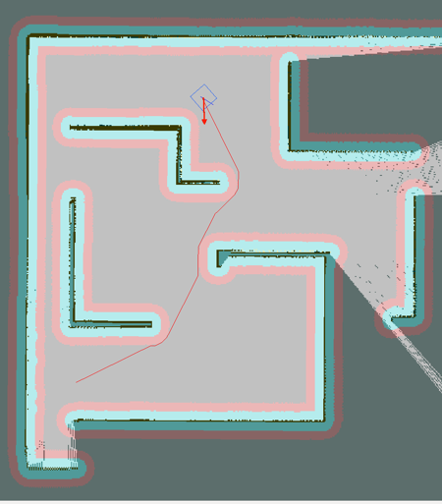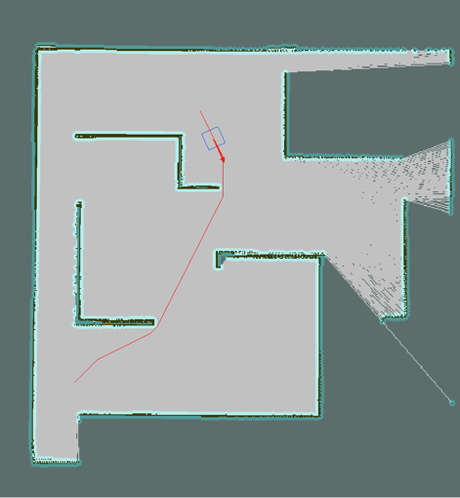

Figure ‑ A 5cm cost map radius of inflation (Left) and a larger, 30cm radius (Right)

### Quality of global plan

The AD* algorithm used for global planning can provide a suboptimal solution and then improves that solution within the allocated time. There is always a trade-off between the optimality and the speed of the result. Two parameters that control the trade-off is the epsilon and the allocated time. Increasing epsilon, makes the algorithm provide a faster solution but of less quality. The allocated time is the time after which the algorithm stops improving the solution. Figure 4-3 shows the global plan when epsilon is given a value of 1, while allocated time is given a value of 10 seconds. It can be shown that the global plan is optimum as epsilon holds its minimum value. Figure 4-3 also shows the global plan when epsilon is given a value of 10 and allocated time is given a value of 1 second. The plan is shown to be suboptimal because the epsilon value is high and 1 second of allocated time is not enough time for improvement.

Figure ‑ Path obtained with epsilon = 1 and time = 5 seconds (Left) compared to a path obtained with epsilon = 10 and time = 1 second (Right)

## Robot-Generated Maps

In order for a map to be generated, the depth sensing system acquires a point cloud of its field of view, which is subsequently projected into a 2D plane, mimicking a laser scan. Figure 4-3 shows an example of a point cloud acquired by our robot, along with its corresponding generated laser scan.

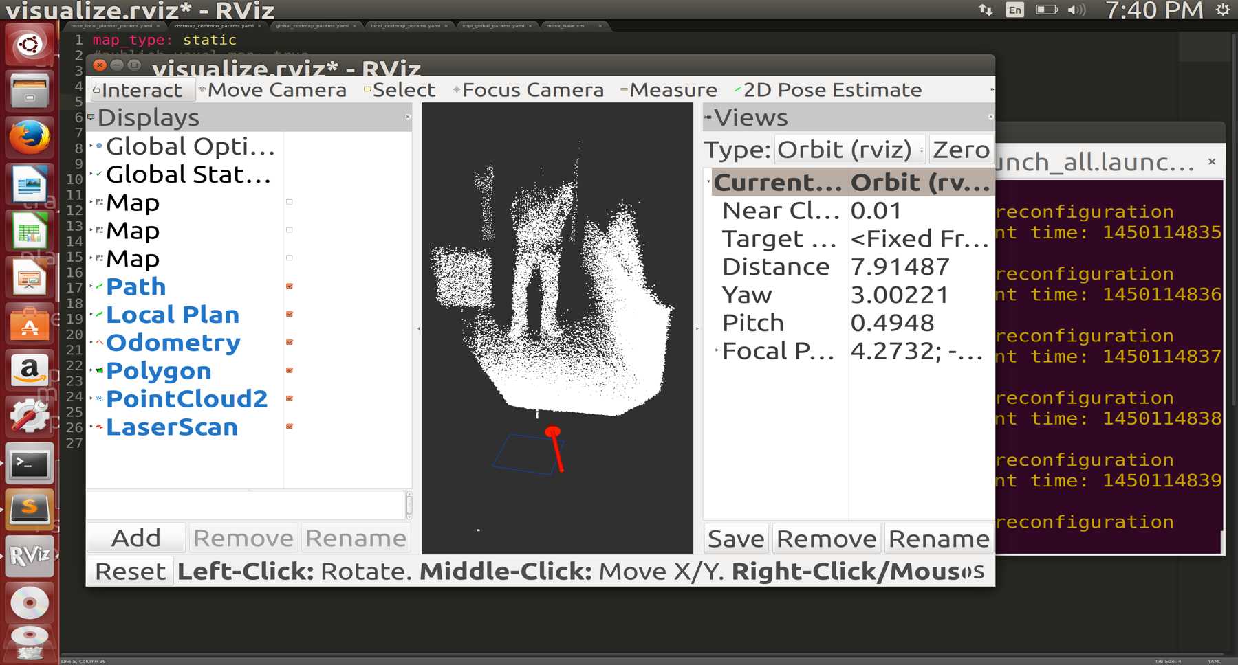 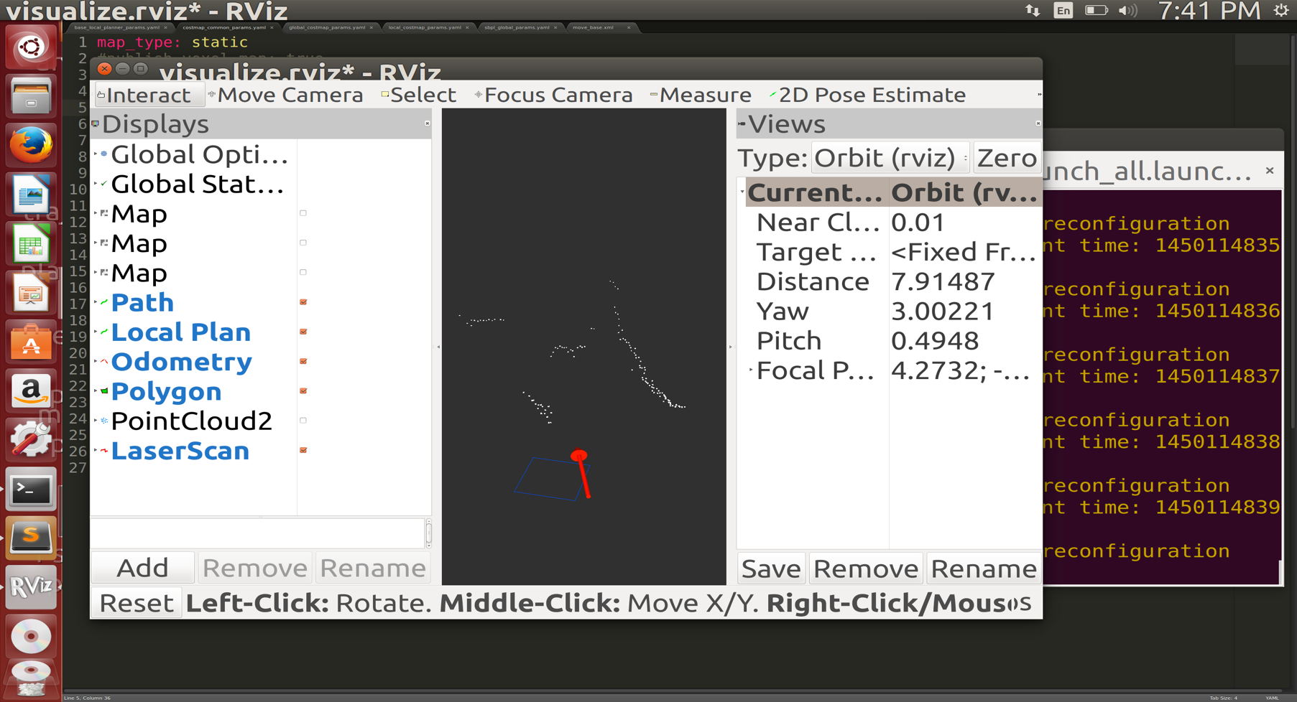

Figure ‑ Point cloud of a person and a wall acquired by the system (left) and corresponding 2D laser scan (right). The red arrow shows the odometry published by the robot.

The SLAM subsystem makes use of the laser scan data, along with the odometry information to incrementally construct a map and localize the robot as it moves. As mentioned in Chapter 3, the SLAM gmapping package has a large number of configurable parameters. Figure 4-5 shows two maps obtained by our robot of a room. The left image shows the map obtained using the default parameters of the gmapping, while the right shows an improved map after tuning a number of parameters to better suit our robot. It is clear that significant improvements can be made with a better tuned configuration.

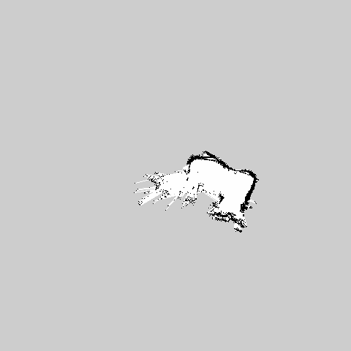 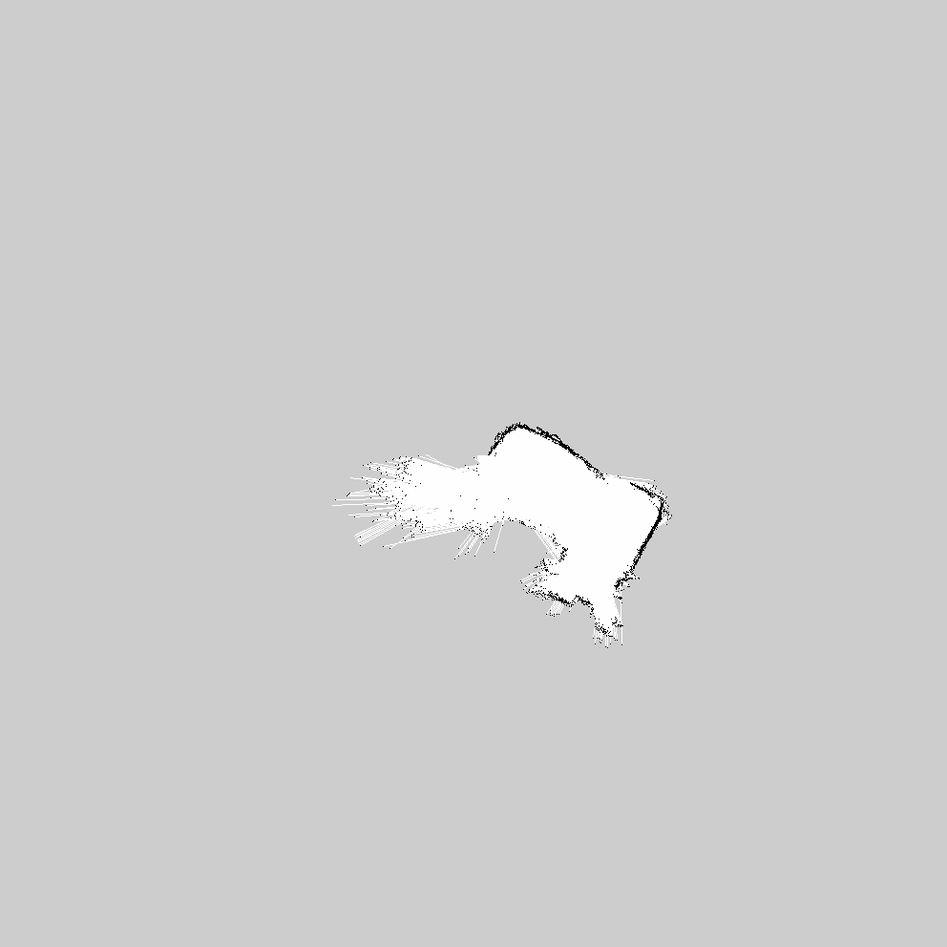

Figure ‑ Map obtained by robot using default gmapping parameters (left) and tuned gmapping parameters (right)

This difference is even more pronounced when mapping larger areas in which accumulated drift becomes significant. In such situations, short range sensors such as our camera are liable to poor localization results and can therefore produce unintelligible maps. To account for this, we increased the minimum threshold to consider scan matching by the particle filter to be successful, which dramatically improved the quality of larger scale maps. The effect of this single parameter can be seen in Figure 4-6.

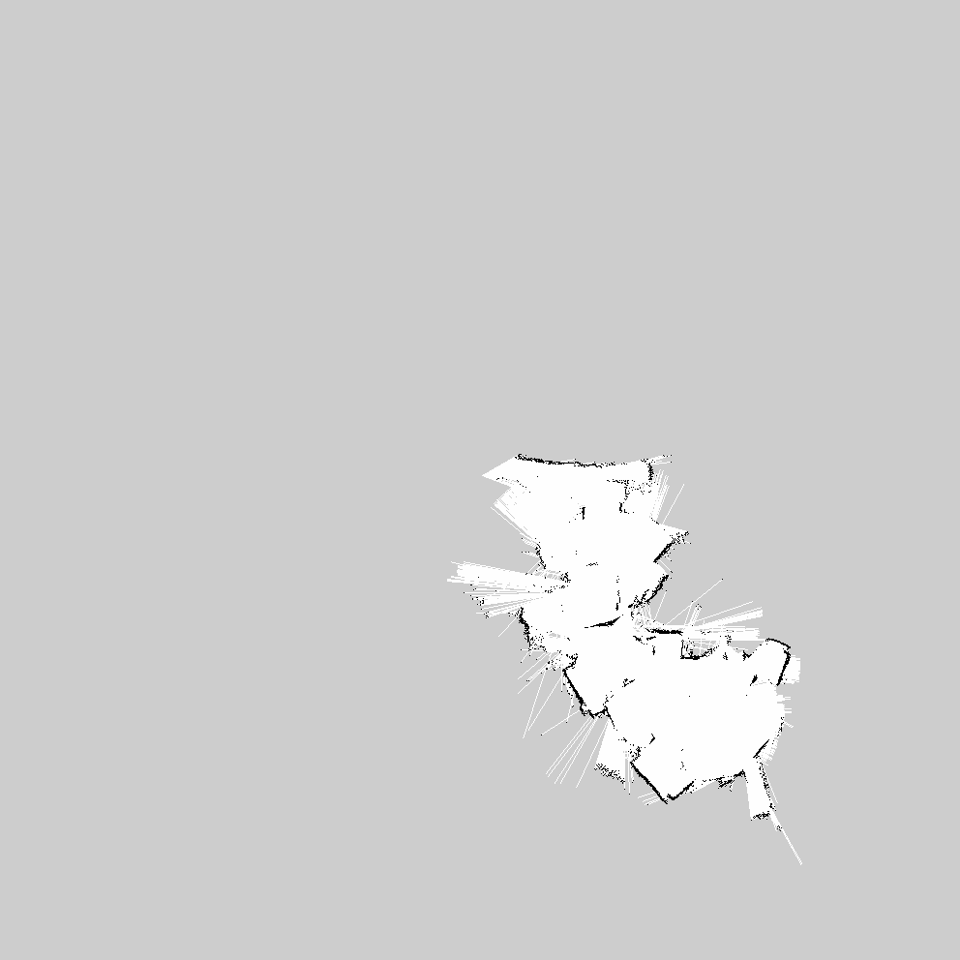 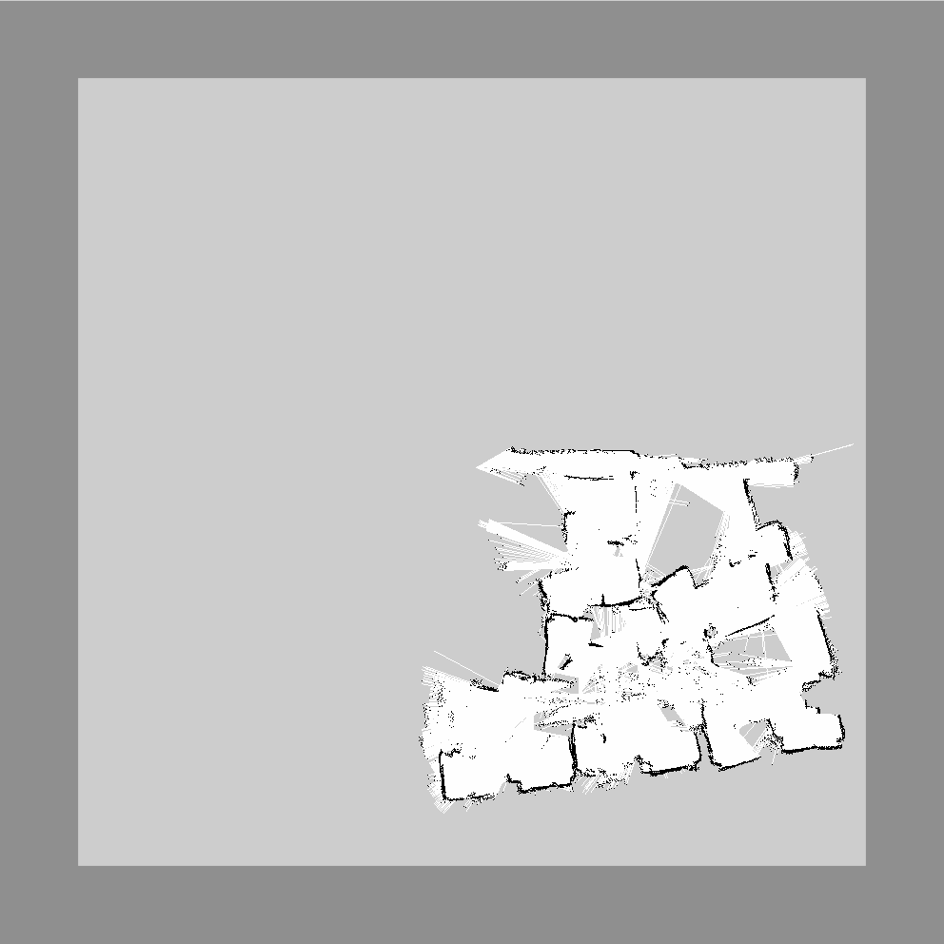

Figure ‑ Drift resulting in an unintelligible map (left) which is significantly improved by increasing the scan matching minimum score (right)

Adding the path planner to the system inflates map boundaries so that the robot can navigate around obstacles. Figures 4-7 and 4-8 show maps produced in real-time by the system with SLAM and path planning running of large labs.

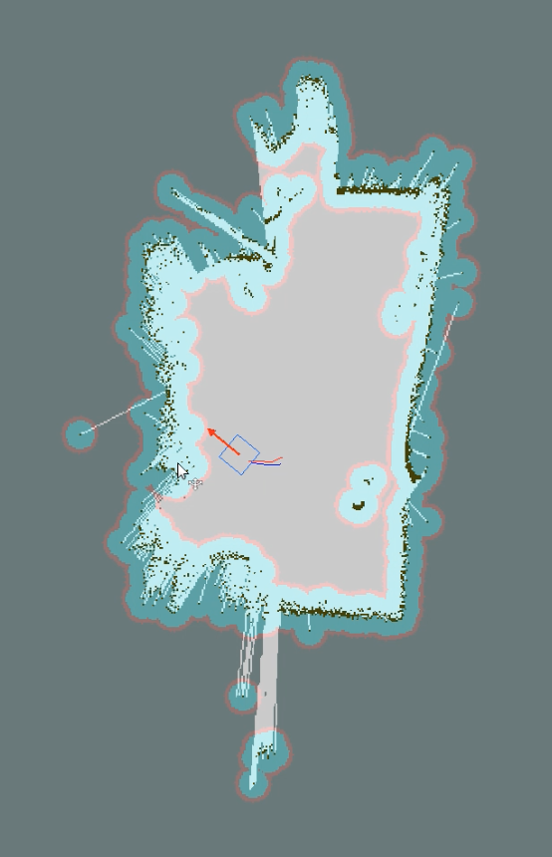

Figure ‑ Map produced by the system including inflated obstacles from the path planner

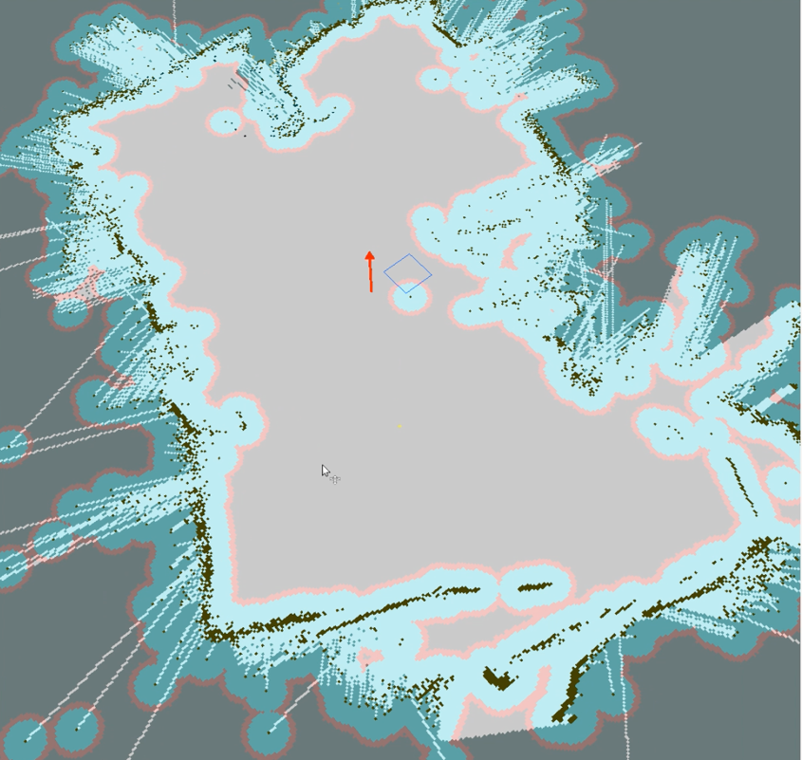

Figure ‑ Larger-scale map produced by the system

# Challenges and Future Work

In this chapter, we detail many of the challenges that we faced while implementing the system and how these challenges were overcome. We then discuss several ways in which the robot could be improved and propose this as future work to be done.

## Challenges

In implementing the system, numerous challenges were faced; the solutions to some of which have significantly altered the final design. These challenges included:

* **The car motors were too fast, making it difficult to control the car, causing the path planner to oscillate because of over-shooting.** To deal with this, we ended up changing the original wheels to smaller-radius wheels, thus achieving lower speeds with the same motor RPM.
* **Odometry was not accurate enough for mapping purposes.** We alleviated this by making better use of the wheel encoder to capture 16 ticks per revolution instead of 8. Also used smaller wheels on the car to enhance the tick resolution.
* **SoftKinetic camera did not work on the Raspberry Pi because of a memory bandwidth bottleneck and missing drivers.** We ended up having to switch to the more powerful, driver-supported NVidia Jetson TK1 board.
* **Wi-Fi and USB serial communication were not supported by the Jetson TK1 board.** We installed a community-developed kernel that added many drivers to the Jetson board, including the necessary ones for our Wi-Fi module and USB serial communication.
* **Arduino serial port overflowed when communicating with ROS.** We manually increased the maximum allowable buffer size for the microcontroller while lowering the publishing rate to avoid errors.
* **Separate coordinate frames defined in the depth sensing camera node resulted in a disjoint transformation tree which failed to run.** We manually changed the source code of the camera node to adjust the coordinate frames to the ones we needed.
* **The laser scan would diverge from the map and no longer function when the robot failed to localize itself in the map.** This turned out to be related to the transform tree. We adjusted the TF tree to tie the laser scan to the robot rather than the map.
* **Scan matching failed on the robot when mapping similar looking regions in the same map.** Thegmapping package parameters were tuned to account for the short range of the laser scan to accommodate poorer scan matching.
* **Communication over Wi-Fi failed when sending time-stamped data.** We thereforeused Internet clock synch to synchronize the two machines.
* **Wi-Fi link was often unreliable.** This lead to us using our own router and static IPs to have better control over the link and dedicating all the bandwidth to our system.
* **Depth sensing range was very limited (2.5m), which made mapping significantly more difficult and required more driving from the car to cover the same area.** We changed the source code of the camera node to alter the camera configuration to a much lower frame rate (6fps instead of 30fps), but an improved range (4m).

## Future Work

While the objectives of the system were met, there are numerous improvements that can be made to the system, both in terms of system performance, and in terms of the cost of the system. These include:

* **Running the control system directly on the embedded board, interfacing with the motor driver using the GPIO pins on the board**. This would eliminate the need for a separate Arduino microcontroller and a USB serial communication link, reducing the cost and area needed for the system, as well as making it more robust by removing a potential source of failure at the USB link.
* **Using a different frame for the car**.We believe that the same results can be achieved with a non-metal frame car since it added no benefit to the objective. An identical system could be implemented on an acrylic frame car, reducing the cost of the system by almost EGP 900.00. Alternatively, a different frame altogether could be used that does not resemble a car, such as that of the iRobot Roomba mentioned in Chapter 1.
* **Using a better car and/or wheel encoders**. The SLAM system greatly benefits from improved odometry so focusing on this area could yield significantly better maps. Similarly, the path planner would benefit from better execution of motion commands and improved odometry readings.
* **Extending the range of the depth camera.** This could be done either by purchasing a longer range depth camera, or by attempting to rewrite the software used by the camera, trading frame rate for greater depth. Once again, mapping benefits significantly from more accurate, and greater range depth data. This would also make it possible for larger areas to be mapped.
* **Extending the field of view of the depth camera**. This could be done using a fish-eye lens for example, widening the field of view at the cost of lower resolution. We found the resolution to be more than what is needed however, so there is little harm in lowering it and much to gain for mapping and obstacle avoidance if a wider field of view is available.

The above improvements are specific to our current setup. There are also significant alterations that can be made to the system from the point of view of algorithms.

* **Constructing 3D maps of the environment.** While this was infeasible with the Raspberry Pi because of its limited memory bandwidth, the Jetson board has enough bandwidth along with GPU acceleration to make 3D mapping a feasible task. Of course, alternative methods would have to be used in place of Rao-Blackwellized particle filtering.
* **Mapping using a monocular camera instead of an RGB-D camera.** Again, with the computational power of the Jetson board, it could be possible to substitute the expensive SoftKinetic camera for a much cheaper monocular camera. Though it does not produce depth data directly, computer vision techniques can be used to extract depth data using consecutive frames while the robot is in motion. This would significantly reduce the cost of the system, since the depth camera currently accounts for about 30% of the system cost.

# References

|  |  |
| --- | --- |
| [1] | iRobot Roomba – iRobot [Online]. Available: <http://www.irobot.com/for-the-home/vacuum-cleaning/roomba.aspx> |
| [2] | Google Self-Driving Car Project [Online]. Available: <https://plus.google.com/+GoogleSelf-DrivingCars/> |
| [3] | PrecisionHawk Agricultural UAV [Online]. Available: <http://www.precisionhawk.com> |
| [4] | Siegwart, Roland, and Illah Reza Nourbakhsh. “Introduction to Autonomous Mobile Robots”. Cambridge, MA: MIT, 2004. Print. |
| [5] | Velodyne HDL-32E – Velodyne [Online]. Available: http://velodynelidar.com/hdl-32e.html |
| [6] | A. Davison, I. Reid, N. Molton, and O. Stasse, “MonoSLAM: Real-Time Single Camera SLAM” in *IEEE Transactions on Pattern Analysis and Machine Intelligence,* June 2007 |
| [7] | Salgado, Graham C., Goodwin, Stefan F. and Graebe, Mario E. “Control System Design”. Upper Saddle River, N. J.: Prentice Hall, 2001. Print. |
| [8] | Rotary Encoders – Arduino [Online]. Available: <http://playground.arduino.cc/Main/Rotary-Encoders> |
| [9] | E. Magnus. Control of Mobile Robots [Online course]. Available: <https://class.coursera.org/conrob-002>, 2014. |
| [10] | A. Stenz, “A Guide to Heuristic-based Path Planning”, 2005. |
| [11] | Elfes, Alberto. "Using occupancy grids for mobile robot perception and navigation", in *Computer* 22.6: 46-57, 1989. |
| [12] | Thrun, Sebastian, Wolfram Burgard, and Dieter Fox. “Probabilistic Robotics”. Cambridge, MA: MIT, 2005. Print. |
| [13] | G. Grisetti, C. Stachniss, W. Burgard, “Improved Techniques for Grid-Mapping with Rao-Blackwellized Particle Filters” in *IEEE Transactions on Robotics*, 2007 |
| [14] | M. Montemerlo, S. Thrun, D. Koller, and B. Wegbreit, “FastSLAM: A Factored Solution to the Simultaneous Localization and Mapping Problem”, in *Proceedings of AAAI National Conference on Artificial Intelligence*, 2002. |
| [15] | H. Asama, A. Yamashita and Y. Ji, "RGB-D SLAM using vanishing point and door plate information in corridor environment," *Intelligent Service Robotics,* vol. 8, pp. 102-114, 2015. |
| [16] | J. Engel, T. Schops and D. Cremers, "LSD-SLAM: Large-Scale Direct Monocular SLAM," in *Computer Vision- EECV: 13th European Conference, Proceedings, Part II*, vol. 8690, Zurich, Springer International, 2014, pp. pp 834-849. |
| [17] | J. Engel, J. Strum and D. Cremers, "Semi-dense Visual Odometry for a Monocular Camera," in *Computer Vision ICCV, IEEE International Conference*, Sydney, NSW, 2013. |
| [18] | J. Strum and e. al, "An evaluation of the RGB-D SLAM system," in *Robotics and Automation (ICRA), International Conference*, Saint Paul, MN, 2012. |
| [19] | N. Engelhard and e. al, "Real-time 3D visual SLAM with a hand-held RGB-D camera," in *Proc. of the RGB-D Workshop on 3D Perception in Robotics at the European Robotics Forum*, Vasteras, Sweden, 2011. |
| [20] | H. P. Quang and N. L. Quoc, "Some improvements in the RGB-D SLAM system."," in *Computing & Communication Technologies-Research, Innovation, and Vision for the Future (RIVF), 2015 IEEE RIVF International Conference on. IEEE*, 2015. |
| [21] | D. Belter, M. Nowicki, P. Skrzypczyński, K. Walas and J. Wietrzykowski, "Lightweight RGB-D SLAM System for Search and Rescue Robots.," *In Progress in Automation, Robotics and Measuring Techniques,* pp. 11-21, 2015. |
| [22] | Y. Tu, Z. Huang, X. Zhang, W. Yu, Yang Xu and B. Chen, "The Mobile Robot SLAM Based on Depth and Visual Sensing in Structured Environment," *Robot Intelligence Technology and Applications 3, Advances in Intelligent Systems and Computing ,* vol. 345, 2015. |
| [23] | "Kerl, C.; Sturm, J.; Cremers, D., "Robust odometry estimation for RGB-D cameras," Robotics and Automation (ICRA), 2013 IEEE International Conference on , vol., no., pp.3748,3754, 6-10 May 2013". |
| [24] | S. Izadi, D. Kim, O. H. D. Molyneaux, R. Newcombe, P. Kohli and J. S. e. al, "KinectFusion: real-time 3D reconstruction and interaction using a moving depth camera," *Proceedings of the 24th annual ACM symposium on User interface software and technology,* pp. pp. 559-568, 2011. |
| [25] | H. Roth and M. Vona, "Moving Volume Kinect Fusion," *BMCV,* 2012. |
| [26] | "Andreasson, H.; Duckett, T.; Lilienthal, A.J., "A Minimalistic Approach to Appearance-Based Visual SLAM," Robotics, IEEE Transactions on , vol.24, no.5, pp.991,1001, Oct. 2008". |
| [27] | ROS – Robot Operating System [Online]. Available: <http://www.ros.org> |
| [28] | ROS Topics –Robot Operating System [Online]. Available: <http://wiki.ros.org/Topics> |
| [29] | “Navigation” – Robot Operating System [Online]. Available: <http://wiki.ros.org/navigation> |
| [30] | “TF” –Robot Operating System [Online]. Available: <http://wiki.ros.org/tf> |
| [31] | "Move Base" Robot Operating System [Online]. Available: http://wiki.ros.org/move_base |
| [32] | “2D Cost Map” Robot Operating System [Online]. Available: <http://wiki.ros.org/costmap_2d> |
| [33] | Search-Based Planning Lab [Online]. Available: <http://sbpl.net/node/48> |
| [34] | Search-Based Planning Lab [Online]. Available: http://sbpl.net/node/52 |
| [35] | “Base Local Planner” Robot Operating System [Online]. Available: http://wiki.ros.org/base_local_planner |
| [36] | “SBPL Lattice Planner” Robot Operating System [Online]. Available: <http://wiki.ros.org/sbpl_lattice_planner> |
| [37] | Search-Based Planning Lab [Online]. Available: <http://sbpl.net/node/50> |
| [38] | “gmapping” Robot Operating System [Online]. Available: <http://wiki.ros.org/gmapping> |
| [39] | "DepthSense® 325," Soft Kinetic, [Online]. Available: http://www.softkinetic.com/Store/ProductID/6. [Accessed 20 10 2015]. |
| [40] | D. S. Canzobre, "Ros Depthsense Camera," 26 April 2015. [Online]. Available: https://gitlab.citius.usc.es/david.sanchez/ros_depthsense_camera. [Accessed 15 10 2015]. |
| [41] | W. Lucetti, "ROS Depthsense Camera," 23 February 2015. [Online]. Available: https://github.com/Myzhar/ros_depthsense_camera. |
| [42] | "Point Cloud to Laser Scan," Robot Operating System, 3 August 2015. [Online]. Available: http://wiki.ros.org/pointcloud_to_laserscan. |
| [43] | P. Bovbel, "Point Cloud To Laser Scan Nodelet," Github, 8 June 2015. [Online]. Available: https://github.com/ros-perception/pointcloud_to_laserscan/blob/indigo-devel/src/pointcloud_to_laserscan_nodelet.cpp. |
| [44] | "Point Cloud 2 Documentation," Robot Operating system, 26 August 2015. [Online]. Available: http://docs.ros.org/api/sensor_msgs/html/msg/PointCloud2.html. |
| [45] | "Laser Scan Documentation," Robot Operating System, 26 August 2015. [Online]. Available: http://docs.ros.org/api/sensor_msgs/html/msg/LaserScan.html. |
| [46] | "Nvidia Jetson TK1 Development Kit Specification," Nvidia, Santa Clara, California, 2014. |
| [47] | N. Hu, "Depth Sense SDK," South Korea, 2014. |
| [48] | "Jetson TK1 Developer Kit," Nvidia, [Online]. Available: http://www.nvidia.com/object/jetson-tk1-embedded-dev-kit.html. |
| [49] | The Stage Robot Simulator [Online]. Available: <http://playerstage.sourceforge.net/doc/stage-svn/> |